Name

Mathematics Advanced Year 12
Further Areas under Curves

Book 3 |  | Version: 261020  Feedback:  https://MrDingMaths.com
Contents
Syllabus Content 2
Area Bounded by a Curve 3
Area Bounded by the $y$-axis 13
Area Between Two Curves 21
Trapezoidal Rule 34
Area under Exponential, Reciprocal, and Trigonometric Curves 43

Syllabus Content
Areas and the definite integral
- Apply $\int_{a}^{b}{f\left(x\right)}dx=F\left(b\right)-F\left(a\right)$, where $F(x)$ is a primitive of $f(x)$, to calculate definite integrals and solve related theoretical problems involving functions within the scope of the Mathematics Advanced course
- Describe, in the case where $f\left(x\right)≥0$ for all values of $x$ in the interval $a≤x≤b$, the area bounded by the graph of the continuous function $y=f(x)$, the $x$-axis and the lines $x=a$ and $x=b$, as $\int_{a}^{b}{f(x)}dx$
- Recognise, in the case where $f\left(x\right)≤0$ for all values of $x$ in the interval $a≤x≤b$, the area bounded by the graph of the continuous function $y=f(x)$, the $x$-axis and the lines $x=a$ and $x=b$, as $\left|\int_{a}^{b}{f(x)}dx\right|$ or $-\int_{a}^{b}{f(x)}dx$
- Conclude, for a continuous function $y=f(x)$ on the interval $a≤x≤b$, that $\int_{a}^{b}{f(x)}dx=$ (area of regions between curve and $x$-axis lying above the $x$-axis) $-$ (area of regions between curve and the $x$-axis lying below the $x$-axis)
- Use definite integrals to solve problems involving the areas of regions bounded by the graph of the continuous function $y=f(x)$, the $x$-axis and the lines $x=a$ and $x=b$, in cases where $f\left(x\right)≥0$throughout $a≤x≤b$, $f\left(x\right)≤0$throughout $a≤x≤b$ or where $f(x)$ changes sign in the interval $a≤x≤b$, with or without the graph provided
- Use definite integrals to solve problems involving the areas of regions bounded by the graph of the continuous function $y=f(x)$, the $y$-axis and the lines $y=a$ and $y=b$, in cases where $x≥0$throughout $a≤y≤b$, $x≤0$throughout $a≤y≤b$ or where $x$ changes sign in the interval $a≤y≤b$ with or without the graph provided
- Use the fact that the graphs of $y=a^{x}$ and $y=\log_{a}{x}$ are reflections of each other in the line $y=x$ to solve problems involving areas between the $x$-axis or $y$-axis and a curve involving either an exponential or logarithmic function
- Recognise and use the result, where $f(x)$ is continuous on the interval $a≤x≤c$, $\int_{a}^{b}{f\left(x\right)dx}+\int_{b}^{c}{f\left(x\right)dx}=\int_{a}^{c}{f\left(x\right)dx}$ for all $c$ such that $a≤b≤c$
- Define and use the result $\int_{a}^{b}{f\left(x\right)dx}=-\int_{b}^{a}{f\left(x\right)dx}$, where $f(x)$ is continuous on the interval $a≤x≤b$
- Recognise and use symmetry, particularly odd and even functions, to simplify and solve integration problems
- Use the Trapezoidal rule to approximate integrals
- Use an online computational application to evaluate definite and indefinite integrals involving functions within and beyond the scope of the Mathematics Advanced course
- Model and solve practical problems involving integrals and areas of regions bounded by a curve and the $x$-axis, or by a curve and the $y$-axis, involving functions within the scope of the Mathematics Advanced course

Area Bounded by a Curve

- Area bounded by a curve
If a question asks for the area bounded by the curve and the $x$-axis, give the positive value.
All $f\left(x\right)≥0$ in region  Area is the definite integral  $$A=\int_{a}^{b}{f\left(x\right)dx}$$ | All $f\left(x\right)≤0$ in region  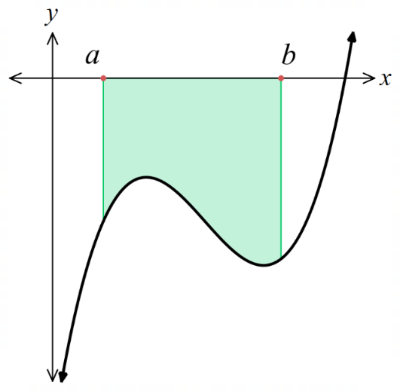  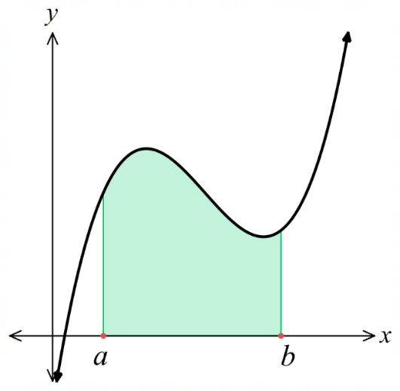  Area is the absolute value of the integral or the negative of the integral  $$A=\left|\int_{a}^{b}{f\left(x\right)dx}\right|=-\int_{a}^{b}{f\left(x\right)dx}$$

- Identify the area bounded by the curve and the $x$ axis using the integral
Find area bounded by:
- $y=2x+1$, the $x$-axis, $x=0$ and $x=3$  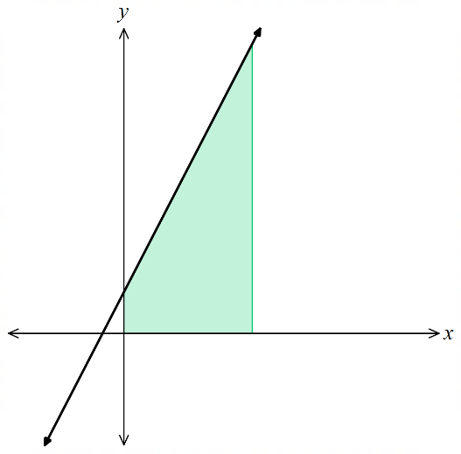 | - $y=4-x^{2}$, the $x$-axis, $x=-2$ and $x=2$  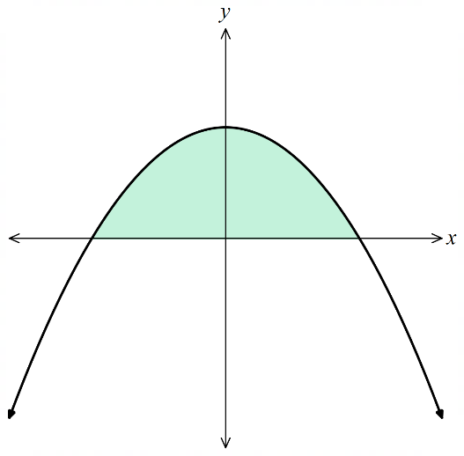 | - $y=x^{2}-4$, the $x$-axis, $x=0$ and $x=2$  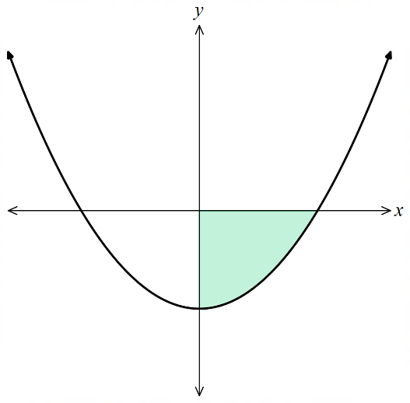
- $y=x^{3}-4x$, the $x$-axis, $x=-2$ and $x=-1$  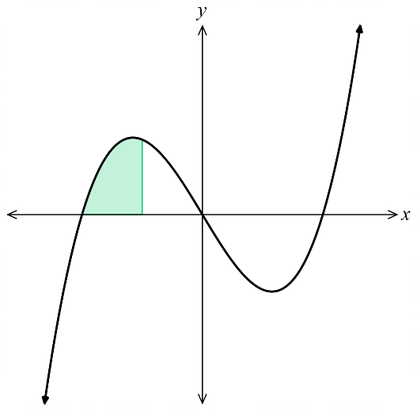 | - $y=x^{2}+1$, the $x$-axis, $x=0$ and $x=2$  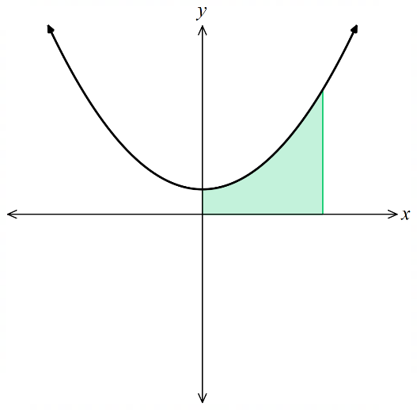 | 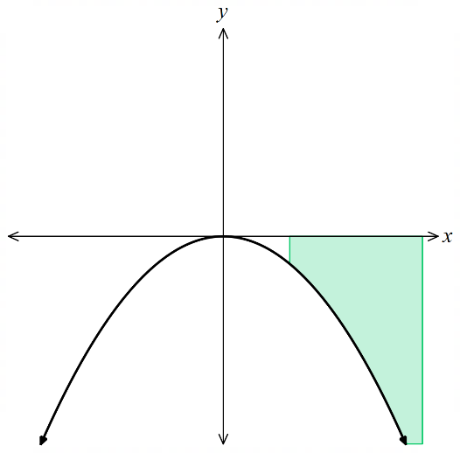  - $y=-x^{2}$, the $x$-axis, $x=1$ and $x=3$
- Area bounded by a curve
If a question asks for the area bounded by the curve and the $x$-axis, give the positive value.
$f\left(x\right)$ changes sign in region
Split the region into smaller regions based on positive and negative definite integrals.
Add the absolute value of all the sub-integrals, or subtract the negative regions.
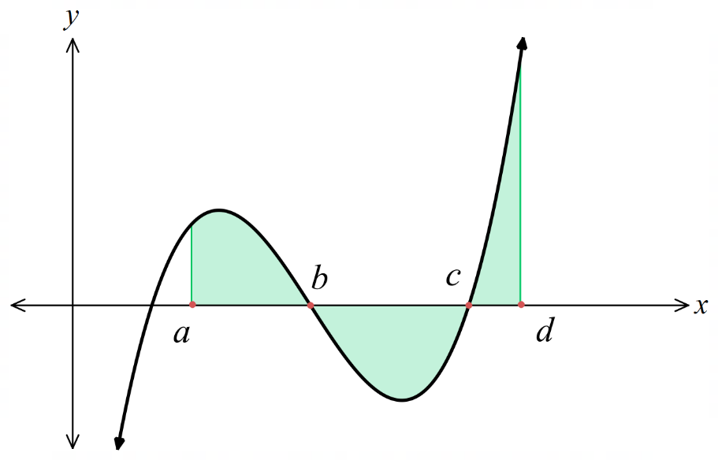
$$A=\int_{a}^{b}{f\left(x\right)dx}+\left|\int_{b}^{c}{f\left(x\right)}dx\right|+\int_{c}^{d}{f\left(x\right)}dx$$
$$=\int_{a}^{b}{f\left(x\right)dx}-\int_{b}^{c}{f\left(x\right)}dx+\int_{c}^{d}{f\left(x\right)}dx$$

- Identify how to split a region to find the area bounded by the curve and $x$-axis
Find an expression for the area of the given region:
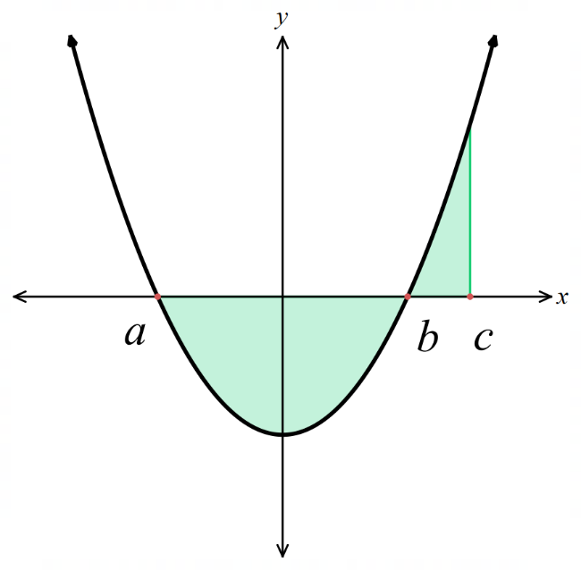 | 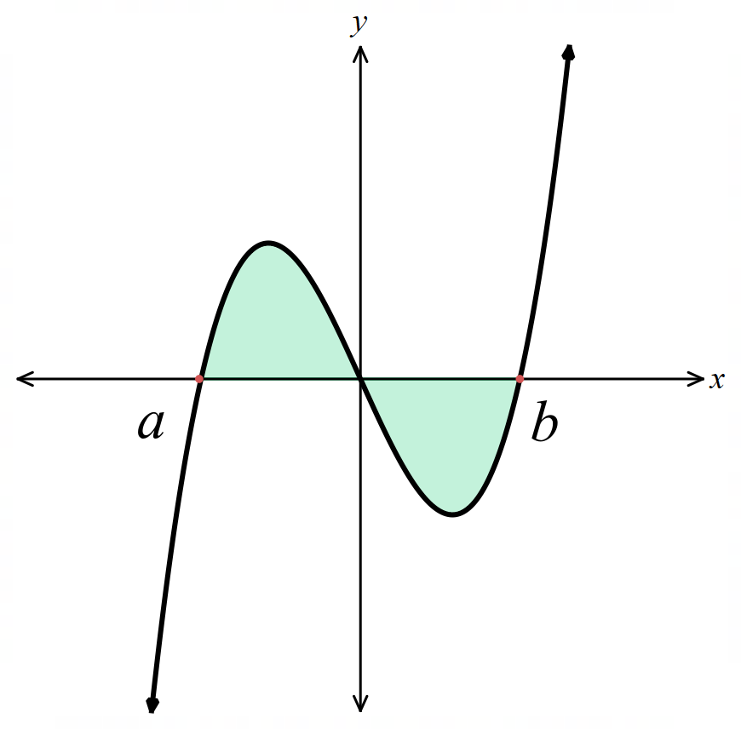 | 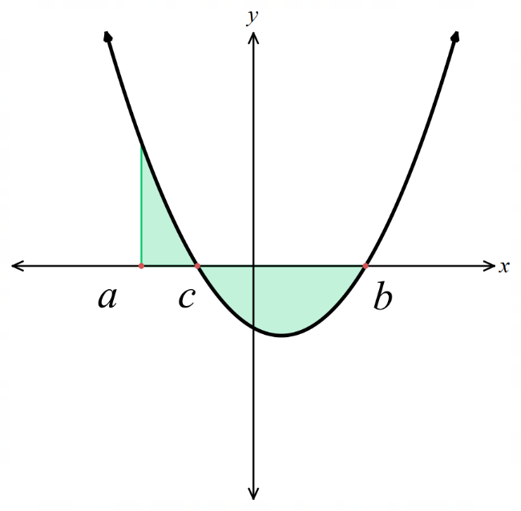
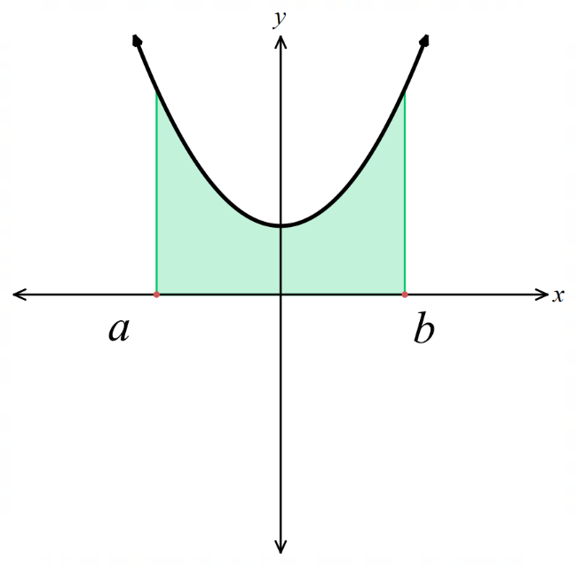 | 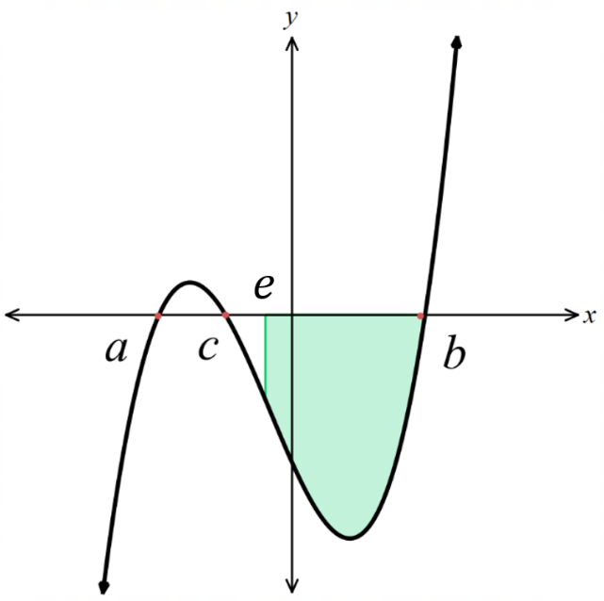 | 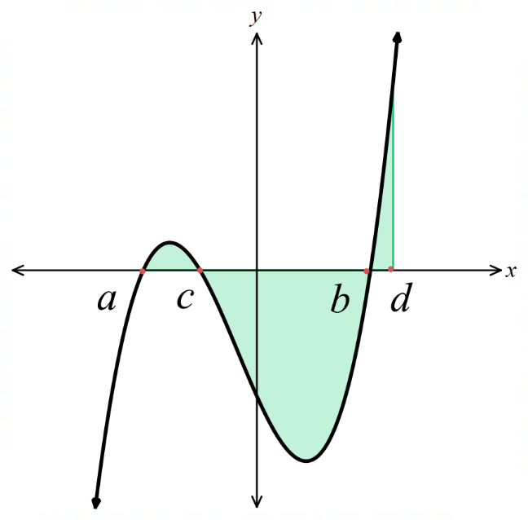
- Area bounded by a curve
To find the area bounded by $y = f(x),$ the $x$-axis, and vertical lines$x=a$ and $x=b$:
- Find the $x$-intercepts by solving $f\left(x\right)=0$.
- Split the integral at each intercept that is within the region $\left[a,b\right]$.
- Sum the absolute values of each sub-integral.

- Example Find the area bounded by a curve and the $x$-axis
Find the area bounded by $y=x^{2}-5x+4$, the $x$-axis, and the lines $x=-1$ and $x=4$.
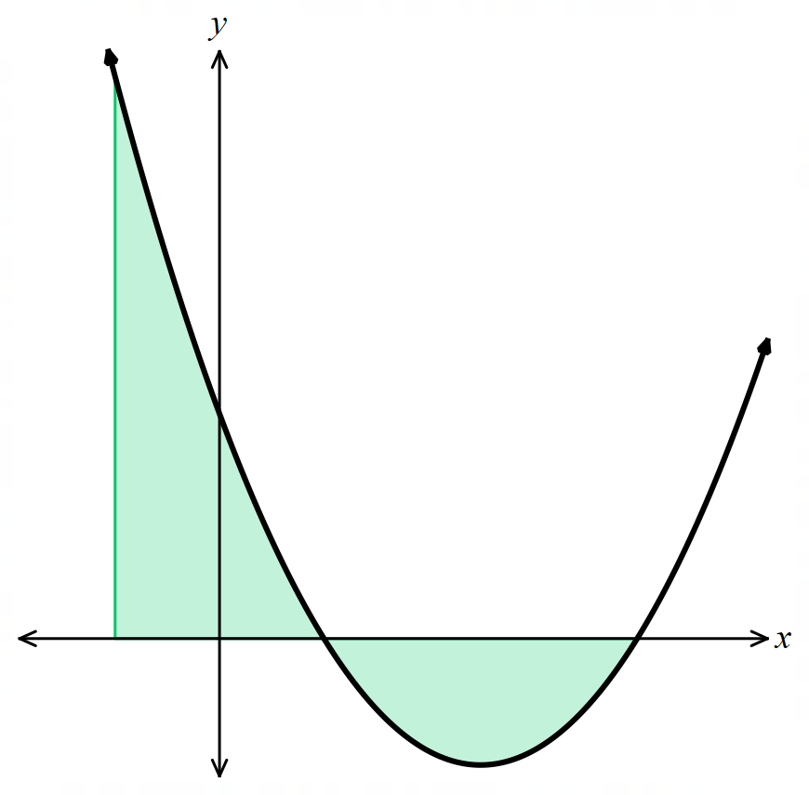
1. Find $x$-intercepts:
$x^{2}-5x+4=0$ $\left(x-4\right)\left(x-1\right)=0$
$x=4, 1$

2. Split integral
$$\int_{-1}^{1}{\left(x^{2}-5x+4\right)}dx+\left|\int_{1}^{4}{\left(x^{2}-5x+4\right)}dx\right|$$

3. Sum absolute values of subintervals
$$={\left[\frac{x^{3}}{3}-\frac{5x^{2}}{2}+4x\right]}_{-1}^{1}+\left|{\left[\frac{x^{3}}{3}-\frac{5x^{2}}{2}+4x\right]}_{1}^{4}\right|$$
$$=\left(\frac{1}{3}-\frac{5}{2}+4\right)-\left(-\frac{1}{3}-\frac{5}{2}-4\right)+\left|\left(\frac{64}{3}-\frac{80}{2}+16\right)-\left(\frac{1}{3}-\frac{5}{2}+4\right)\right|$$
$$=\frac{26}{3}+\left|-\frac{9}{2}\right|$$
$$=\frac{79}{6}=13.1\dot{6} {units}^{2}$$

- Guided Practice
- Find the area bounded by $y=x²-x-2$, the $x$-axis, and lines $x=-2$ and $x=1$.
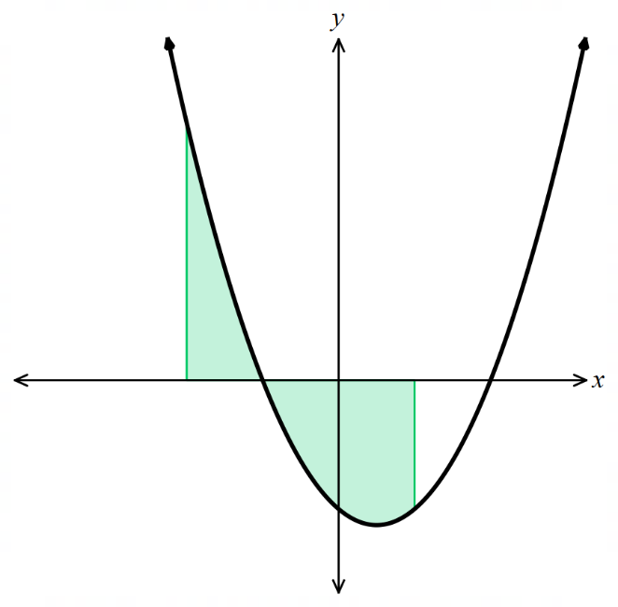

$$\frac{31}{6} u^{2}$$
- Find the area enclosed between the $x$ axis and $y=x\left(x+1\right)\left(x-2\right)$.
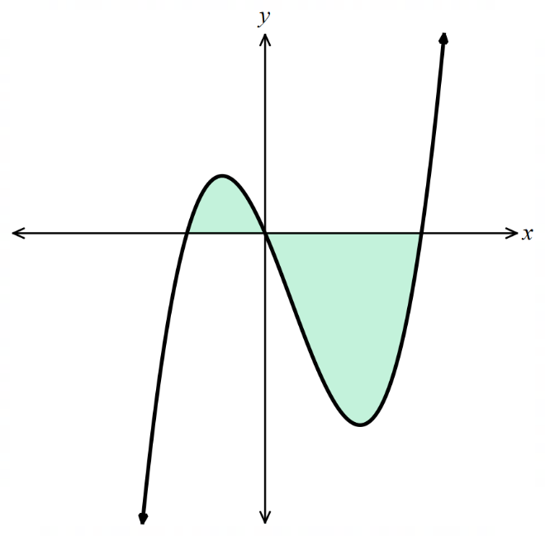

$$\frac{37}{12} u^{2}$$

- Key Ideas
- The key difference between 'evaluate the integral' and 'find the area' is that area is always ……………………
- If you are asked to find the area between $f\left(x\right)$ and the $x$-axis between $x∈\left[a,b\right]$:
  - If $f(x) ≥ 0$ throughout: Area = ……………………
  - If $f(x) ≤ 0$ throughout: Area = ……………………
  - If $f(x)$ changes sign: ……………… the integral at each intercept

Foundation
- Find the area of each shaded region below by evaluating the appropriate integral.
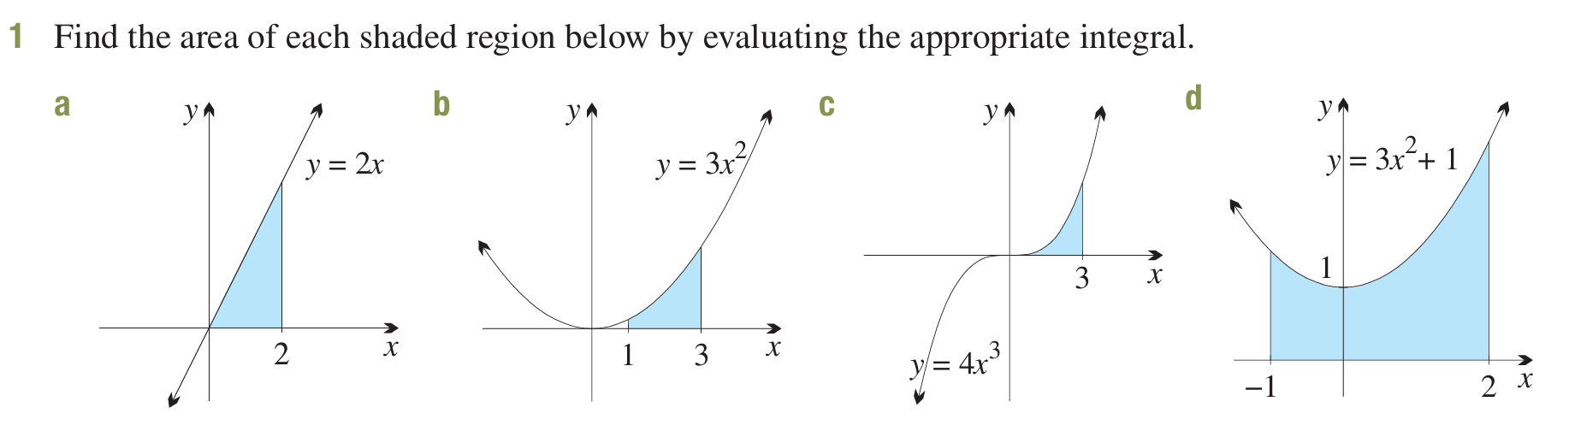  4 u² | 26 u² | 81 u²
12 u² | 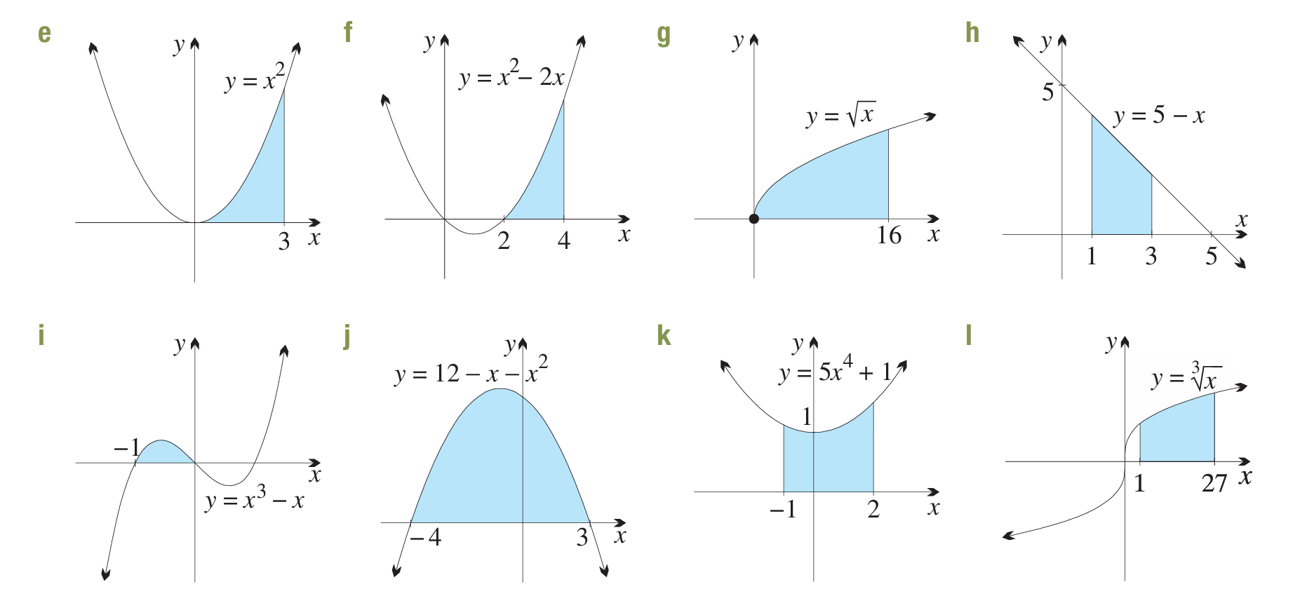  9 u² | $$\frac{20}{3} u^{2}$$
$$\frac{128}{3} u^{2}$$ | 6 u² | $$\frac{1}{4} u^{2}$$
$$\frac{343}{6} u^{2}$$ | 36 u² | 60 u²
- Find the area of each shaded region below by evaluating the appropriate integral.
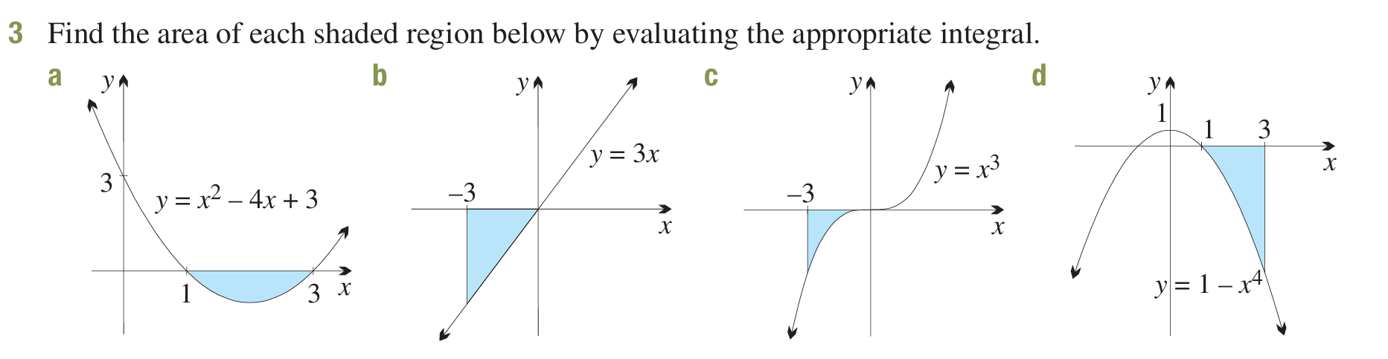  $$\frac{4}{3} u^{2}$$ | $$\frac{27}{2} u^{2}$$
$$\frac{81}{4} u^{2}$$ | $$46\frac{2}{5} u^{2}$$

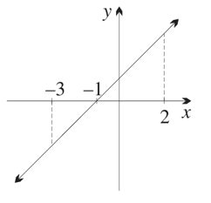
- The line $y=x+1$ is graphed.
  - Shade the region between the line $y=x+1$
and the $x$-axis from $x=-3$ to $x=2$.
  - By evaluating $\int_{-1}^{2}{\left(x + 1\right)}dx$,
find the area of the shaded region above the $x$-axis.

4.5 u²
  - By evaluating $\int_{-3}^{-1}{\left(x + 1\right)}dx$,
find the area of the shaded region below the $x$-axis.

2 u²
  - Hence find the area of the entire shaded region.

6.5 u²
  - Find $\int_{-3}^{2}{\left(x + 1\right)}dx$, and explain why this integral does not give the area of the shaded region.
2.5 u²
This is the area above the $x$-axis minus the area below it, not the total area.

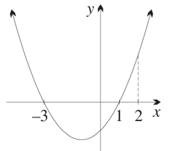
- The curve $y=\left(x-1\right)\left(x+3\right)=x^{2}+2x-3$ is graphed.
  - Shade the region between the curve $y=\left(x-1\right)\left(x+3\right)$
and the $x$-axis from $x=-3$ to $x=2$.
  - By evaluating $\int_{-3}^{1}{\left(x^{2}+ 2x - 3\right)}dx$,
find the area of the shaded region below the $x$-axis.

$$10\frac{2}{3} u^{2}$$
  - By evaluating $\int_{1}^{2}{\left(x^{2}+ 2x - 3\right)}dx$,
find the area of the shaded region above the $x$-axis.

$$2\frac{1}{3} u^{2}$$
  - Hence find the area of the entire shaded region.

13 u²
  - Find $\int_{-3}^{2}{\left(x^{2}+ 2x - 3\right)}dx$, and explain why this integral does not give the area of the shaded region.

$$-8\frac{1}{3} u^{2}$$
This is the area above the $x$-axis minus the area below it, not the total area.

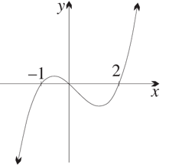
- The curve $y = x\left(x + 1\right)\left(x - 2\right)= x^{3}- x^{2}- 2x$ is graphed.
  - Shade the region bounded by the curve and the $x$-axis.
  - By evaluating $\int_{0}^{2}{\left(x^{3}- x^{2}- 2x\right)}dx$,
find the area of the shaded region below the $x$-axis.

$$2\frac{2}{3} u^{2}$$
  - By evaluating $\int_{-1}^{0}{\left(x^{3}- x^{2}- 2x\right)}dx$,
find the area of the shaded region above the $x$-axis.

$$\frac{5}{12} u^{2}$$
  - Hence find the area of the entire region you have shaded.
$$3\frac{1}{12} u^{2}$$
  - Find $\int_{-1}^{2}{\left(x^{3}- x^{2}- 2x\right)}dx$, and explain why this integral does not give the area of the shaded region.
$$- 2\frac{1}{4} u^{2}$$
This is the area above the $x$-axis minus the area below it, not the total area.

Development
- In each part, find the area of the region bounded by the graph of the function and the $x$-axis between the specified values. Areas above and below the $x$-axis must be calculated separately.
A sketch of the curve will help.
  - $y = x²,$ between $x = -3$ and $x = 2$

$y = x²,$ always ≥ 0, so entire region is above x-axis.
$$A = \int_{-3}^{2}{x^{2}} dx = \left[\frac{x^{3}}{3}\right]-3^{2}=\frac{8}{3}+ 9 =\frac{35}{3}= 11\frac{2}{3}u^{2}$$
  - $y = 2x³,$ between $x = -4$ and $x = 1$

$y = 2x³,$ zero at $x$ = 0. Below $x$-axis on [−4, 0], above on [0, 1].
$$Below: -\int_{-4}^{0}{2x^{3}}dx = -\left[\frac{x^{4}}{2}\right]-4^{0}= -\left(0 - 128\right)= 128$$
$$Above: \int_{0}^{1}{2x^{3}}dx = {\left[\frac{x^{4}}{2}\right]}_{0}^{1}=\frac{1}{2}$$
$$Total = 128 +\frac{1}{2}= 128\frac{1}{2}u^{2}$$
  - $y = 3x(x - 2),$between $x = 0$ and $x = 2$
$y = 3x(x - 2),$ zeros at $x = 0$and $x = 2$. Below $x$-axis on (0, 2).
$$A = -\int_{0}^{2}{\left(3x^{2}- 6x\right)}dx$$
$$= -{\left[x^{3}- 3x^{2}\right]}_{0}^{2}$$
$$= -\left[\left(8 - 12\right)- 0\right]$$
= 4 u²
  - $y = x - 3$, between $x = -1$ and $x = 4$

$y = x - 3$, zero at $x = 3$. Below $x$-axis on [−1, 3], above on [3, 4].
$$Below: -\int_{-1}^{3}{\left(x - 3\right)}dx = -\left[\frac{x^{2}}{2}- 3x\right]-1^{3}= -\left[\left(\frac{9}{2}- 9\right)- \left(\frac{1}{2}+ 3\right)\right]= 8$$
$$Above: \int_{3}^{4}{\left(x - 3\right)}dx = {\left[\frac{x^{2}}{2}- 3x\right]}_{3}^{4}= \left(8 - 12\right)- \left(\frac{9}{2}- 9\right)=\frac{1}{2}$$
$$Total = 8 +\frac{1}{2}= 8\frac{1}{2}u^{2}$$

  - $y = (x - 1)(x + 3)(x - 2)$, between $x = -3$ and $x = 2$
$$y=x³ - 7x + 6$$
Zeros at $x = -3, 1, 2.$
On (−3, 1): check $x = 0, y = 6 > 0$, above.
On (1, 2): check $x = 1.5, y = -1.125$, below.
$$F\left(x\right)=\frac{x^{4}}{4}-\frac{7x^{2}}{2}+ 6x$$
$$F\left(-3\right)=-\frac{117}{4}, F\left(1\right)=\frac{11}{4}, F\left(2\right)= 2$$
$$Above: F\left(1\right)- F\left(-3\right)=\frac{11}{4}+\frac{117}{4}=32$$
$$Below: -\left[F\left(2\right)- F\left(1\right)\right]= -\left[2 -\frac{11}{4}\right]=\frac{3}{4}$$
$$Total = 32 +\frac{3}{4}= 32\frac{3}{4}u^{2}$$
  - $y = -2x(x + 1)$, between $x = -2$ and $x = 2$
$y = -2x\left(x + 1\right)= -2x^{2}- 2x$, zeros at $x = -1$ and $x = 0.$
On (−2, −1): check $x = -1.5, y = -1.5$, below.
On (−1, 0): check $x = -0.5, y = 0.5$, above.
On (0, 2): check $x = 1, y = -4$, below.
$$F\left(x\right)= -\frac{2x^{3}}{3}- x^{2}$$
$$F\left(-2\right)=\frac{4}{3}, F\left(-1\right)=-\frac{1}{3}, F\left(0\right)= 0, F(2) = -\frac{28}{3}$$
$$Below on \left[-2, -1\right]: -\left[F\left(-1\right)- F\left(-2\right)\right]=\frac{5}{3}$$
$$Above on \left[-1, 0\right]: F\left(0\right)- F\left(-1\right)=\frac{1}{3}$$
$$Below on \left[0, 2\right]: -\left[F\left(2\right)- F\left(0\right)\right]=\frac{28}{3}$$
$$Total =\frac{5}{3}+\frac{1}{3}+\frac{28}{3}=\frac{34}{3}u^{2}$$
- Look carefully for any symmetries that will simplify the calculation.
Find the area of the region bounded by the given curve and the x-axis.
  - $y=x^{7},$for$-2≤x≤ 2$

$y = x⁷$ is odd, so the area on [−2, 0] equals the area on [0, 2]. On [0, 2], curve is above x-axis.
$$A = 2\int_{0}^{2}{x^{7}}dx = 2{\left[\frac{x^{8}}{8}\right]}_{0}^{2}= 2\left(\frac{256}{8}\right) = 64 u²$$
  - $y=x^{3}- 16x=x\left(x - 4\right)\left(x + 4\right),$for$-4 ≤ x ≤ 4$

$y = x³ - 16x = x(x - 4)(x + 4).$ Odd function, so symmetric about origin. Zeros at $x = -4, 0, 4.$
On [0, 4], $y = x(x - 4)(x + 4) ≤ 0$ (check x = 2: 2(−2)(6) = −24, below x-axis).
By symmetry: $A = 2 × \left(-\int_{0}^{4}{\left(x^{3}- 16x\right)}dx\right)$
$$\int_{0}^{4}{\left(x^{3}- 16x\right)}dx = {\left[\frac{x^{4}}{4}- 8x^{2}\right]}_{0}^{4}= \left(64 - 128\right)= -64$$
$A = 2(64) = 128$ u²

  - $y=x^{4}- 9x^{2}=x^{2}\left(x - 3\right)\left(x + 3\right),$for$-3 ≤ x ≤ 3$

$y = x⁴ - 9x² = x²(x - 3)(x + 3).$ Even function, so symmetric about y-axis. Zeros at $x = -3, 0, 3.$
On [0, 3], curve is below x-axis (check x = 1: 1 − 9 = −8).
$$A = 2 × \left(-\int_{0}^{3}{\left(x^{4}- 9x^{2}\right)}dx\right)$$
$$\int_{0}^{3}{\left(x^{4}- 9x^{2}\right)}dx = {\left[\frac{x^{5}}{5}- 3x^{3}\right]}_{0}^{3}= \left(\frac{243}{5}- 81\right)=-\frac{162}{5}$$
$$A = 2\left(\frac{162}{5}\right)=\frac{324}{5}= 64\frac{4}{5}u^{2}$$

- Find the area of the region bounded by $y = |x + 2|$ and the $x$-axis, for −$2 ≤x≤ 2$.

$y = |x + 2|,$ zero at $x = -2$. For $-2 ≤ x ≤ 2$, we have $x + 2 ≥ 0$, so $y = x + 2.$
$$A = \int_{-2}^{2}{\left(x + 2\right)} dx$$
$$= \left[\frac{x^{2}}{2}+ 2x\right]-2^{2}$$
$$= (2 + 4) - \left(2 - 4\right)$$
= 8 u²

Area Bounded by the $y$-axis

- Review
- Rearrange to make $x$ the subject
- $y=x+1$ | - $y=x^{3}$ | - $y=\sqrt{x+1}$

- Dummy Variable Property
The value of a definite integral only depends on the limits and the integrand.
The variable name can be anything.

$$\int_{a}^{b}{f\left(x\right)}dx=\int_{a}^{b}{f\left(y\right)}dy=\int_{a}^{b}{f\left(t\right)}dt=\int_{a}^{b}{f\left(θ\right)}dθ$$

- Integrate with any variable
Find each indefinite integral.
- $\int{\left(m+1\right)}dm$ | - $\int{\left(t^{2}-7\right)}dt$ | - $\int{\left(h^{7}+5\right)}dh$
- $\int{\left(y-3\right)}dy$ | - $\int{\left(b^{2}+b\right)}db$ | - $\int{\left(2y+4\right)}dy$
- If $\frac{dx}{dt}$ $={\left(t-3\right)}^{2}$ and $x=7$ when $t=0,$ find then $t=4$.

$$\frac{49}{3}$$
- The velocity of an object is given by $\frac{dx}{dt}$ $=6t-5$. If the object has initial displacement of −2, find the equation for the displacement.

$$x = 3t^{2}- 5t - 2$$
- The rate of flow of water into a dam is given by $R=500+20t L h⁻¹.$ If there is 15 000 L of water initially in the dam, how much water will there be in the dam after 10 hours?

$$21000 L$$

- Integrating with Respect to $y$
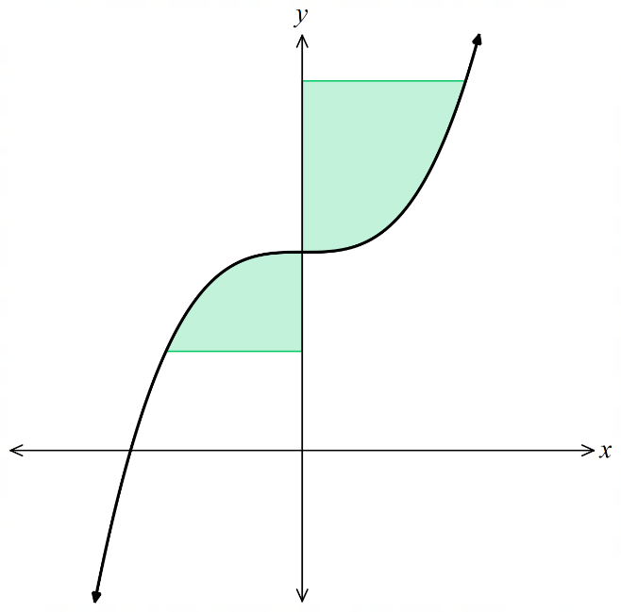
The area bounded by a curve and the $y$-axis is:

$$\int_{a}^{b}{f\left(y\right)}dy$$

- The definite integral returns a positive value when the
function is to the right of the $y$-axis and a negative value
when the function is to the left of the $y$-axis.
- Split the integral at the $y$-intercepts if there are areas left of the $y$-axis.

- Example Find area bound by a function and the $y$-axis
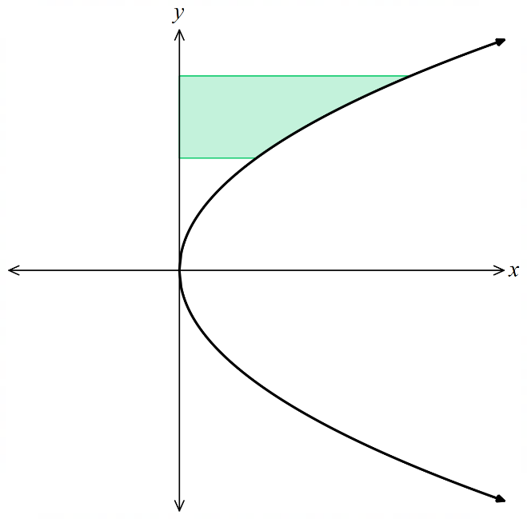
Find the area bounded by $x=y^{2}$, the $y$-axis, $y=1$ and $y=3.$
$$\int_{1}^{3}{y^{2}}dy$$
$$={\left[\frac{y^{3}}{3}\right]}_{1}^{3}$$
$$=\left(\frac{27}{3}\right)-\left(\frac{1}{3}\right)$$
$$=\frac{26}{3} u^{2}$$

- Guided Practice
- Find the area between $x=\sqrt[3]{y-1}$  the $y$-axis, and $y=1, y=2$  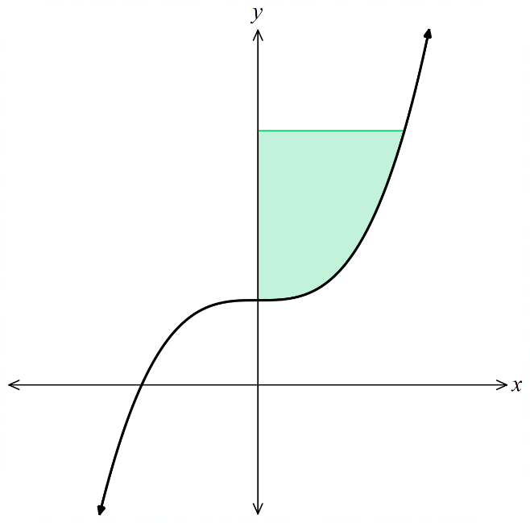  $$\frac{3}{4} u^{2}$$ | - Find the area between $x=y\left(y-2\right)$ and the lines $y=0$ and $y=$ $\frac{5}{2}$  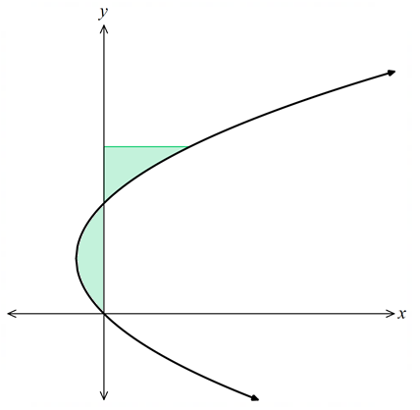  $$\frac{13}{8} u^{2}$$
- Integrating with Respect to $y$
Sometimes you may need to find the area between the curve and the $y$-axis.
- If the function is in terms of $x$, rearrange it in terms of $y$.
- If the limits are in terms of $x$, convert them to the equivalent in $y$.
- Integrate with new limits and integrand.
- Split the integral at the $y$-intercepts if there are areas left of the $y$-axis.

- Example Find area bound by a function and the $y$-axis
Find the area bounded by $y=x^{3}$, the $y$-axis, $x=0$ and $x=2.$
1. Rearrange function  $$y=x^{3}$$  $$x=\sqrt[3]{y}$$  2. Change limits  When $x=0, y=0^{3}=0$  $x=2, y=2^{3}=8$ | 3. Integrate  $$\int_{0}^{8}{\sqrt[3]{y}}dy={\left[\frac{y^{\frac{4}{3}}}{\frac{4}{3}}\right]}_{0}^{8}$$  $$=12-0$$  $$=12 u^{2}$$ | 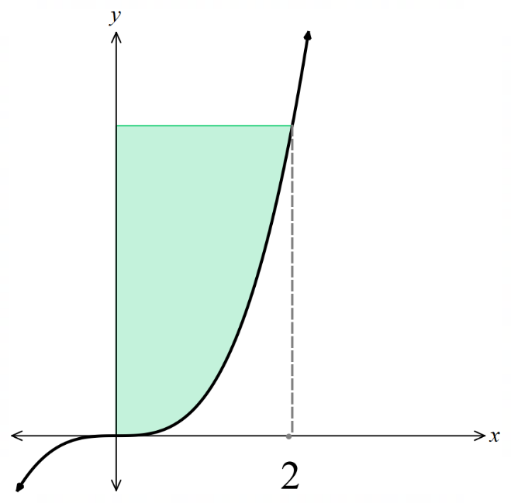

- Guided Practice
- Find the area between $y=x+1$,  the $y$-axis, and $x=0, x=4$  8 | - Find the area between $y=\sqrt{x+1}$ and the lines $x=-1$ and $x=8$  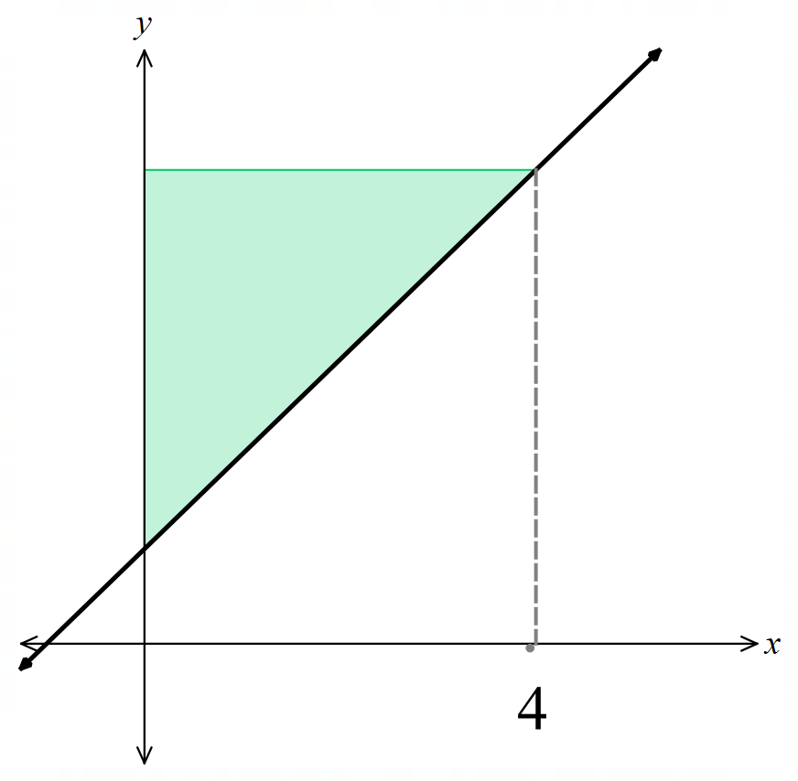  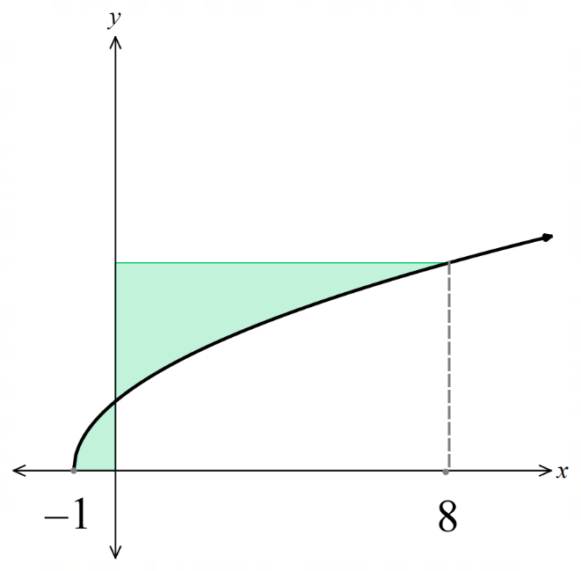  $$7\frac{1}{3}$$

Foundation
- Find the area of each shaded region below by evaluating an integral of the form $\int_{y_{1}}^{y_{2}}{g\left(y\right)}dy$.
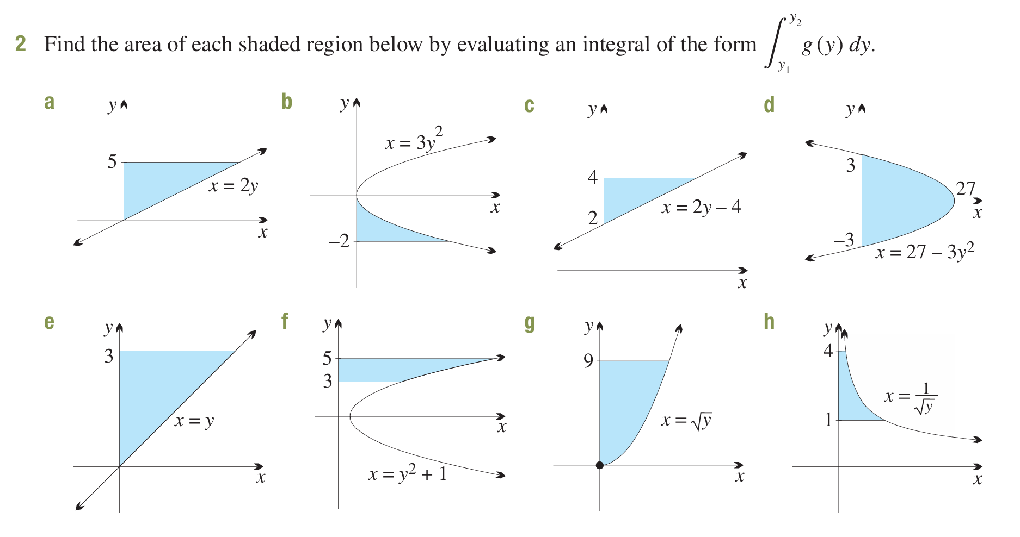  25 u² | 8 u² | 4 u²
108 u² | $$\frac{9}{2} u^{2}$$ | $$34\frac{2}{3} u^{2}$$
18 u² | 2 u²

- Find the area of each shaded region below by evaluating the appropriate integral.
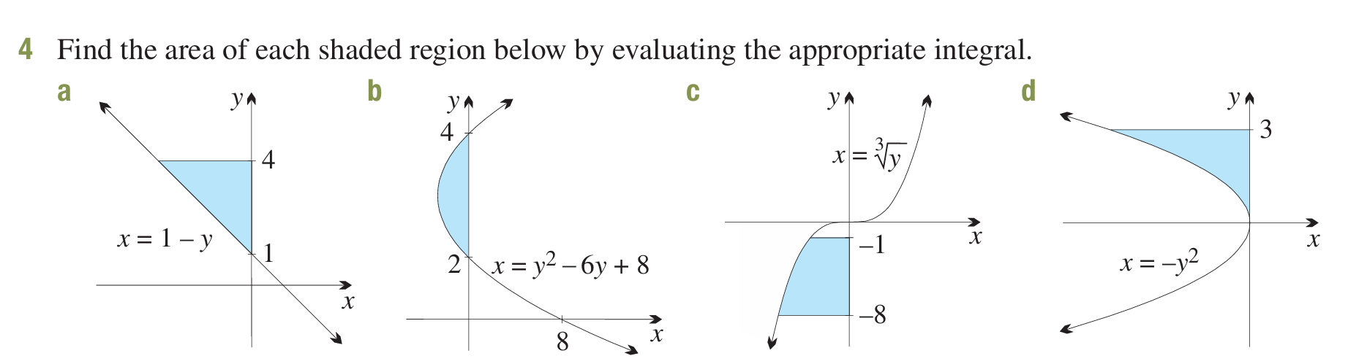  $$\frac{9}{2} u^{2}$$ | $$\frac{4}{3} u^{2}$$
$$\frac{45}{4} u^{2}$$ | 9 u²

- In each part, find the area of the region bounded by function and the $y$-axis between the specified values. Areas to the right and to the left of the $y$-axis must be calculated separately.
  - $x = y - 5$, between $y = 0$ and $y = 6$

$x = y - 5$, zero at $y = 5$. From $y = 0$ to $y = 5, x < 0$ (left of y-axis). From $y = 5$to $y = 6, x > 0$.
$$Left:-\int_{0}^{5}{\left(y - 5\right)}dy = -{\left[\frac{y^{2}}{2}- 5y\right]}_{0}^{5}= -\left(\frac{25}{2}- 25\right)=\frac{25}{2}$$
$$Right: \int_{5}^{6}{\left(y - 5\right)}dy = {\left[\frac{y^{2}}{2}- 5y\right]}_{5}^{6}= \left(18 - 30\right)- \left(\frac{25}{2}- 25\right)=\frac{1}{2}$$
$$Total =\frac{25}{2}+\frac{1}{2}= 13 u^{2}$$
  - $x = 3 - y$, between $y = 2$ and $y = 5$

$x = 3 - y,$ zero at $y = 3$. From $y = 2$to $y = 3, x > 0.$From $y = 3$to $y = 5, x < 0$.
$$Right: \int_{2}^{3}{\left(3 - y\right)}dy = {\left[3y -\frac{y^{2}}{2}\right]}_{2}^{3}= \left(9 -\frac{9}{2}\right)- \left(6 - 2\right)=\frac{1}{2}$$
$$Left: -\int_{3}^{5}{\left(3 - y\right)}dy = -{\left[3y -\frac{y^{2}}{2}\right]}_{3}^{5}= -\left[\left(15 -\frac{25}{2}\right)- \left(9 -\frac{9}{2}\right)\right]= 2$$
$$Total =\frac{1}{2}+ 2 =\frac{5}{2}= 2\frac{1}{2}u^{2}$$

  - $x = y²$, between $y = -1$ and $y = 3$

$x = y²$, always ≥ 0 (right of y-axis). From $y = -1$ to $y = 3$, entire region is to the right.
$$A = \int_{-1}^{3}{y^{2}}dy = \left[\frac{y^{3}}{3}\right]-1^{3}= 9 +\frac{1}{3}= 9\frac{1}{3}u^{2}$$

  - $x = (y - 1)(y + 1)$, between $y = 3$ and $y = 0$

$x = (y - 1)(y + 1) = y² - 1,$ zeros at $y = ±1$. Right of $y$-axis when $|y| > 1$, left when $|y| < 1$.
From $y = 0$ to $y = 1, x < 0$ (left). From $y = 1$ to $y = 3, x > 0$ (right).
$$Left: -\int_{0}^{1}{\left(y^{2}- 1\right)}dy = -{\left[\frac{y^{3}}{3}- y\right]}_{0}^{1}= -\left(\frac{1}{3}- 1\right)=\frac{2}{3}$$
$$Right: \int_{1}^{3}{\left(y^{2}- 1\right)}dy = {\left[\frac{y^{3}}{3}- y\right]}_{1}^{3}= \left(9 - 3\right)- \left(\frac{1}{3}- 1\right)=\frac{20}{3}$$
$$Total =\frac{2}{3}+\frac{20}{3}= 7\frac{1}{3}u^{2}$$
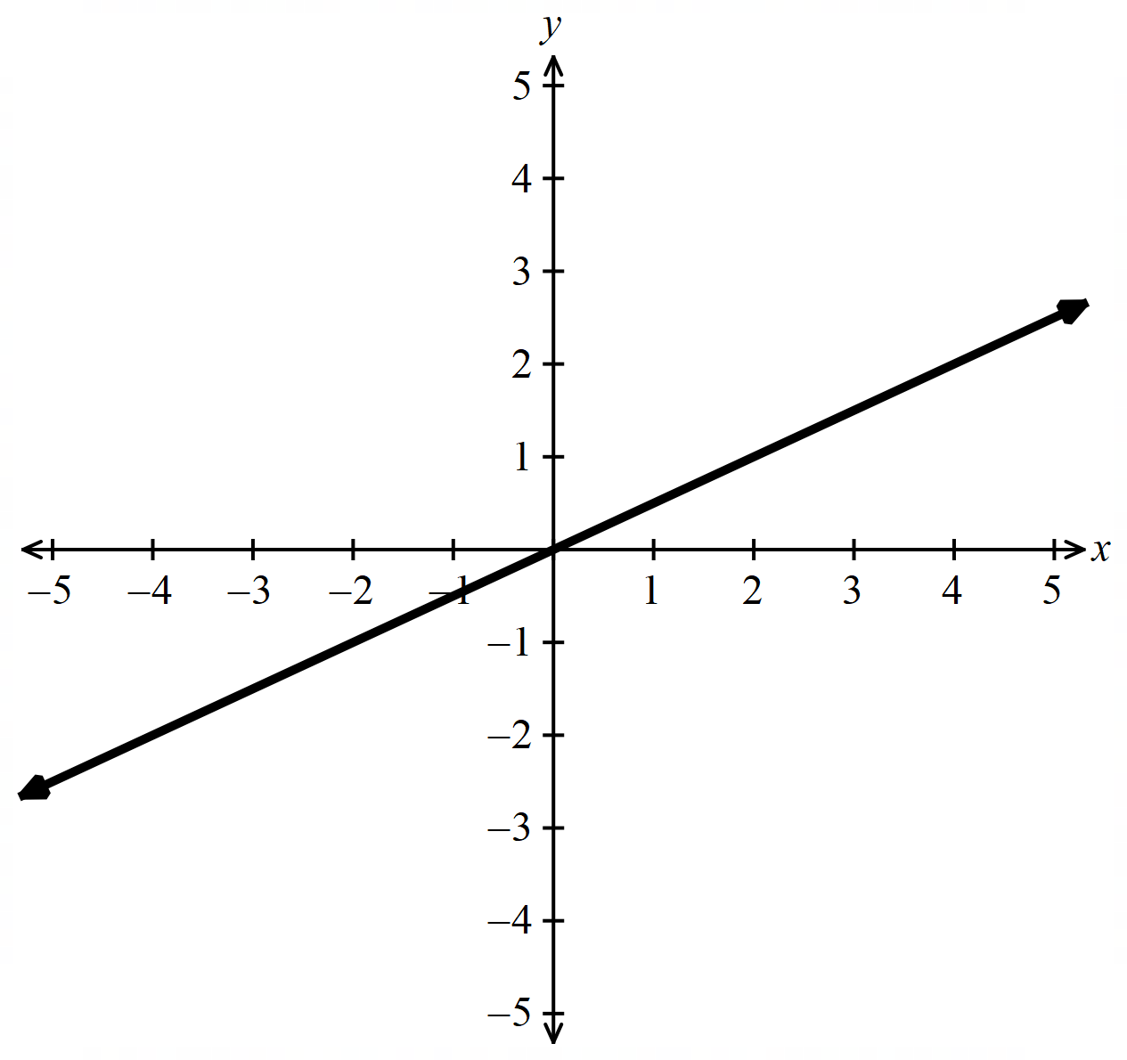
- Sketch the curve and look carefully for any symmetries that will simplify the calculation.
Find the area of the region bounded by the given curve and the $y$-axis.
  - $x=2y,$for$-5 ≤ y ≤ 5$

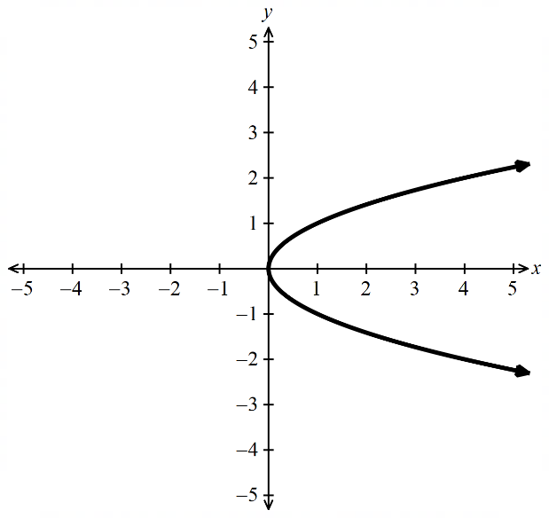
$x = 2y$ is odd in $y$. Right of $y$-axis on (0, 5), left on (−5, 0). By symmetry:
$$A = 2\int_{0}^{5}{2y}dy = 2{\left[y^{2}\right]}_{0}^{5}= 2\left(25\right)= 50 u^{2}$$
  - $x=y²,$for$-3 ≤ y ≤ 3$

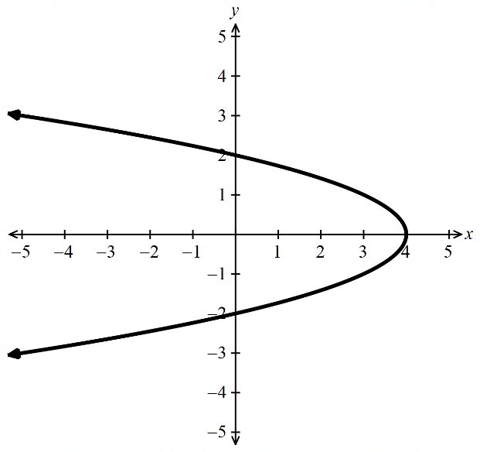
$x = y²$, always ≥ 0. Even function, symmetric about x-axis. By symmetry:
$$A = 2\int_{0}^{3}{y^{2}}dy = 2{\left[\frac{y^{3}}{3}\right]}_{0}^{3}= 2\left(9\right)= 18 u^{2}$$
  - $x=4-y^{2}=\left(2-y\right)\left(2+y\right),$for$-2 ≤ y ≤ 2$

$x = 4 - y² = (2 - y)(2 + y),$ zeros at $y = ±2$. Right of $y$-axis on (−2, 2). Even function, so:
$$A = 2\int_{0}^{2}{\left(4 - y^{2}\right)}dy = 2{\left[4y -\frac{y^{3}}{3}\right]}_{0}^{2}= 2\left(8 -\frac{8}{3}\right)=\frac{32}{3}u^{2}$$

Development
- The diagram shows the parabola $y²= 16(2 - x).$
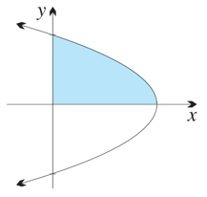
  - Find the $x$-intercept and the $y$-intercepts.

$x$-intercept: set $y = 0,$ so $0 = 16(2 - x), x = 2$. Intercept: (2, 0).
$y$-intercepts: set $x = 0$, so $y² = 32, y = ±4\sqrt{2}$. Intercepts: $\left(0, 4\sqrt{2}\right)$ and $\left(0, -4\sqrt{2}\right)$.
  - Find the exact area of the shaded region:
    - by integrating $y = 4\sqrt{2 - x}$ with respect to $x$.

$$A = \int_{0}^{2}{4\sqrt{2 - x}}dx$$
$$= 4{\left[-\frac{2{\left(2 - x\right)}^{\frac{3}{2}}}{3}\right]}_{0}^{2}$$
$$= 4\left[0 +\frac{2\left(2\sqrt{2}\right)}{3}\right]$$
$$= 16\frac{\sqrt{2}}{3}u^{2}$$
    - by integrating with respect to $y$. (You will need to make $x$ the subject of the equation.)

$$x = 2 -\frac{y^{2}}{16}$$
$$A = \int_{0}^{4\sqrt{2}}{\left(2 -\frac{y^{2}}{16}\right)}dy$$
$$= {\left[2y -\frac{y^{3}}{48}\right]}_{0}^{4\sqrt{2}}$$
$$= 8\sqrt{2}-\frac{128\sqrt{2}}{48}$$
$$= 16\frac{\sqrt{2}}{3}u^{2}$$
- Find the area bounded by the line $y=2x+1$, the $y$-axis and the lines $y = 3$ and $y = 4$.
Need to make $x$ the subject. $x=$ $\frac{y-1}{2}$
$$A = \int_{3}^{4}{\frac{y - 1}{2}}dy$$
$$= \left(\frac{1}{2}\right){\left[\frac{y^{2}}{2}- y\right]}_{3}^{4}$$
$$= \left(\frac{1}{2}\right)\left[\left(8 - 4\right)- \left(\frac{9}{2}- 3\right)\right]$$
$$=\frac{5}{4}= 1\frac{1}{4}units^{2}$$

Mastery
- Find the area enclosed by the curve $y = \sqrt{3x - 5}$, the $y$-axis and the lines $y=2$ and $y=3$.

$$A = \int_{2}^{3}{\frac{y^{2}+ 5}{3}}dy$$
$$= \left(\frac{1}{3}\right){\left[\frac{y^{3}}{3}+ 5y\right]}_{2}^{3}$$
$$= \left(\frac{1}{3}\right)\left[\left(9 + 15\right)- \left(\frac{8}{3}+ 10\right)\right]$$
$$=\frac{34}{9}= 3\frac{7}{9}units^{2}$$
- Find the area enclosed between the curve $y = x^{3}- 2$ and the $y$-axis between $y = -1$and $y = 25.$

$$A = \int_{-1}^{25}{{\left(y + 2\right)}^{\frac{1}{3}}}dy$$
$$= {\left[\left(\frac{3}{4}\right){\left(y + 2\right)}^{\frac{4}{3}}\right]}_{-1}^{25}$$
$$= \left(\frac{3}{4}\right)\left[81 - 1\right]$$
$$= 60 units²$$
- Find the area in the second quadrant enclosed between the lines $y = 4$ and $y = 1 - x$.

$$A = \int_{1}^{4}{\left(0 - \left(1 - y\right)\right)}dy$$
$$= \int_{1}^{4}{\left(y - 1\right)}dy$$
$$= {\left[\frac{y^{2}}{2}- y\right]}_{1}^{4}$$
$$= (8 - 4) - \left(\frac{1}{2}- 1\right)$$
$$=\frac{9}{2}= 4.5 units^{2}$$
- Find the area bounded by the curve $y = \sqrt{x}$, the $y$-axis, $x = 0$ and $x = 4$.

Need to rearrange for $x$ and change the limits. At $x=0, y=0,$ at $x=0, y=2$
$$A = \int_{0}^{2}{y^{2}}dy$$
$$= {\left[\frac{y^{3}}{3}\right]}_{0}^{2}$$
$$=\frac{8}{3}= 2\frac{2}{3}units^{2}$$
- Find the area enclosed between the curve $y = x³,$ the $y$-axis, $x = 0$ and $x = 2$.
$$A = \int_{0}^{8}{y^{\frac{1}{3}}}dy$$
$$= {\left[\left(\frac{3}{4}\right)y^{\frac{4}{3}}\right]}_{0}^{8}$$
$$= \left(\frac{3}{4}\right)\left(16\right)$$
$$= 12 units^{2}$$

Trapezoidal Rule

- Trapezoidal Rule
An area with an irregular boundary can be approximated as a trapezium.
The area of this trapezium is used to estimate the area.
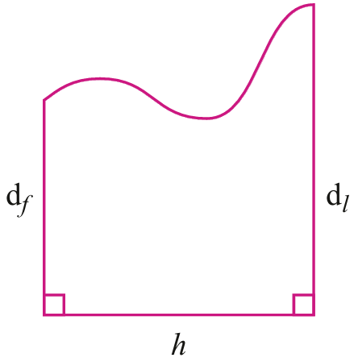

$$A≈\frac{h}{2}\left(d_{f}+d_{l}\right)$$

- Example Estimate area using trapezoidal rule
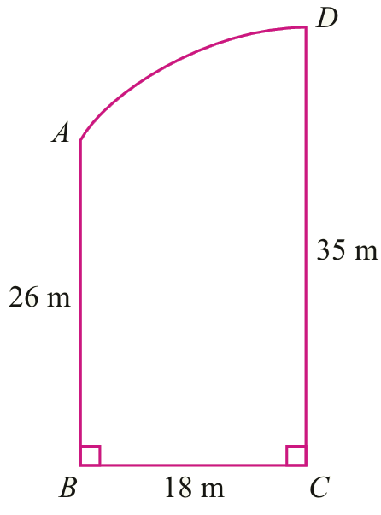
Estimate the area by modelling the area as a trapezium.

$$A≈\frac{h}{2}\left(d_{f}+d_{l}\right)$$
$$≈\frac{18}{2}\left(26+35\right)$$
$≈549 m^{2}$

- Guided Practice
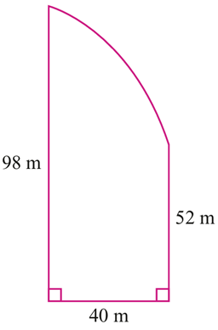
Estimate the area by modelling the area as a trapezium.

3000 $m^{2}$
- Trapezoidal Rule with More Applications
By using more than one application of the trapezoidal rule, we get a more accurate estimate for the area.
Actual Area | 1 Application | 2 Applications

- Example Estimate area using trapezoidal rule
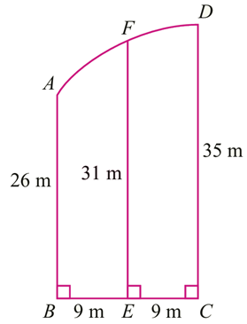
Estimate the area by modelling the area as two trapeziums.

$A≈A_{AFEB}+A_{FDCE}$
$$≈\frac{9}{2}\left(26+31\right)+\frac{9}{2}(31+35)$$
$$≈256.5+297$$
$≈534 m^{2}$

- Guided Practice
Estimate this area to the nearest square metre using two applications of trapezoidal rule.
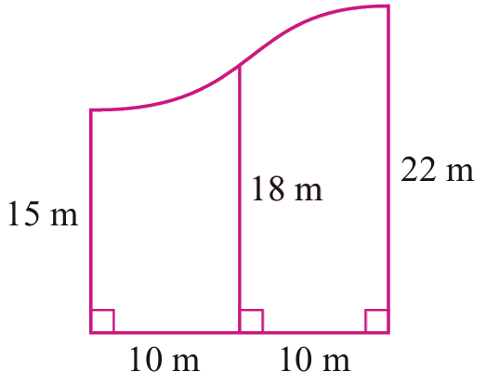  365 m² | 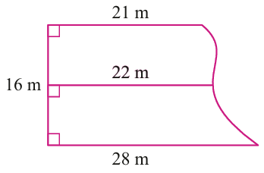  372 m²
- Investigation Trapezoidal rule with Functions
We can approximate areas bounded by functions using trapezoidal rule as well.
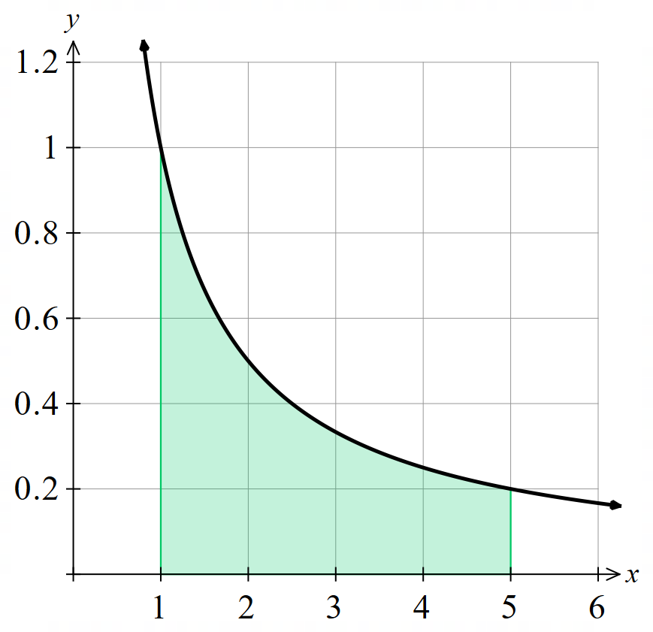
Find the area under $f\left(x\right)=$ $\frac{1}{x}$ using:
1 application of trapezoidal rule:

4 applications of trapezoidal rule:

Check the exact area by evaluating the integral:
$$\int_{1}^{5}{\frac{1}{x}}dx$$

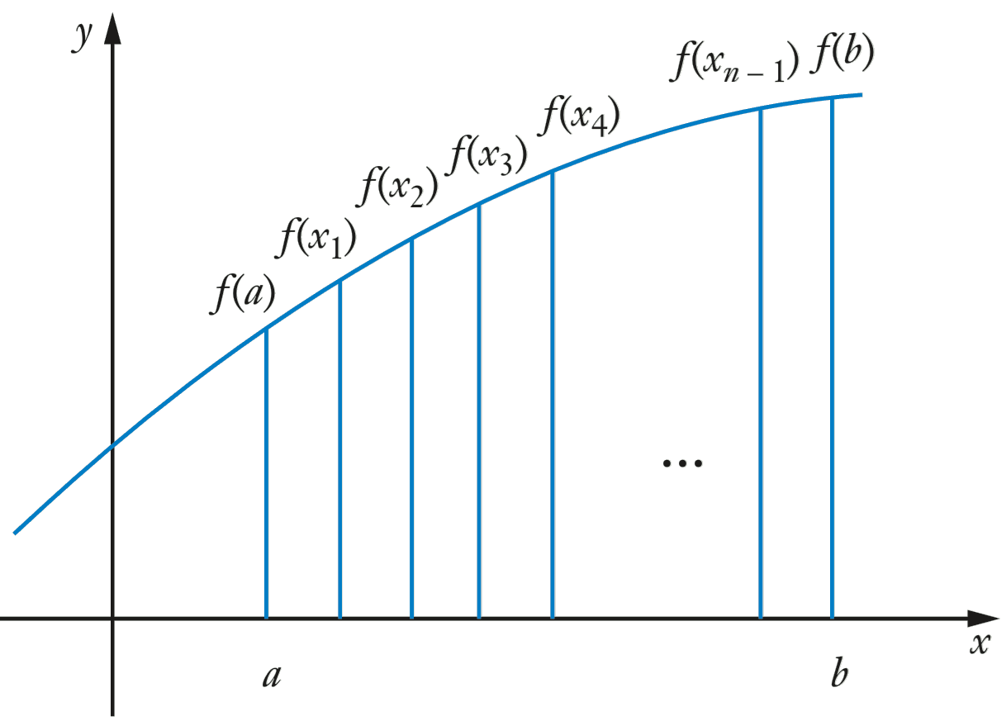
Consider a function with $n$ intervals.

The height of each trapezium is: ……………
The first trapezium has area: ……………

The second trapezium has area: …………

$$\int_{a}^{b}{f\left(x\right)}dx$$
$$≈\frac{b-a}{2n}\left(f\left(a\right)+f\left(x_{1}\right)\right)+\frac{b-a}{2n}\left(f\left(x_{1}\right)+f\left(x_{2}\right)\right)+\frac{b-a}{2n}\left(f\left(x_{2}\right)+f\left(x_{3}\right)\right)…+\frac{b-a}{2n}\left(f\left(x_{n-1}\right)+f\left(b\right)\right)$$
$$≈\frac{b-a}{2n}\left(f\left(a\right)+f\left(x_{1}\right)+f\left(x_{1}\right)+f\left(x_{2}\right)+…\left(f_{n-1}\right)+f\left(b\right)\right)$$
$$≈\frac{b-a}{2n}(f\left(a\right)+f\left(b\right)+2\left(f\left(x_{1}\right)+f\left(x_{2}\right)+…+f\left(x_{n-1}\right)\right)$$

- Trapezoidal Rule with Functions
Sometimes we may want to find the area bounded by a curve but:
- We may not have a function rule.
- It may not be possible to integrate a function algebraically $f\left(x\right)=e^{x^{2}}$.
We can approximate the area by splitting the area up into trapeziums
(this is more accurate than the rectangles we use in Riemann Sums).
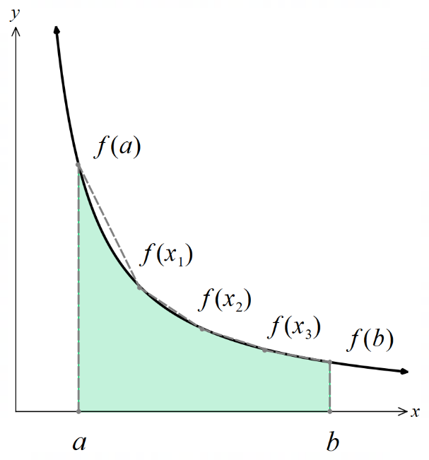  One interval  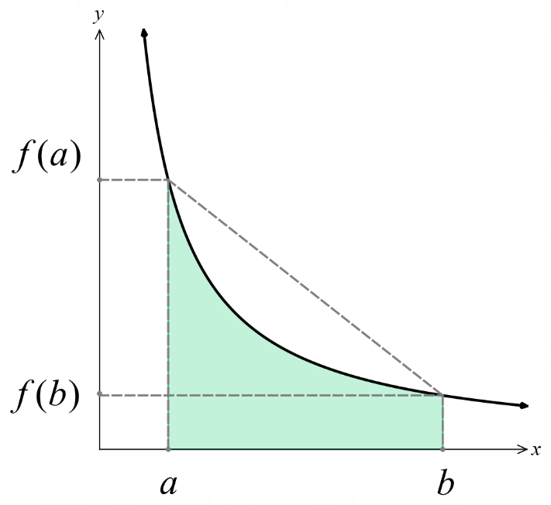  $$\int_{a}^{b}{f\left(x\right)}dx≈\frac{\left(b-a\right)}{2}\left[f\left(a\right)+f\left(b\right)\right]$$ | $n$ intervals  $$\int_{a}^{b}{f\left(x\right)}dx≈\frac{h}{2}\left[f\left(a\right)+f\left(b\right)+2(f\left(x_{1}\right)+…f\left(x_{n-1}\right)\right]$$  $$where h=\frac{b-a}{2}$$
- A clear way of setting out is to first calculate the height of each trapezium and then setting up a table of values with the function values.

- Example Estimate area bounded by functions using trapezoidal rule
$$Find \int_{2}^{3}{\left(\frac{2}{x-1}\right)}dx using 4 subintervals. Round your answer to 3 d.p.$$
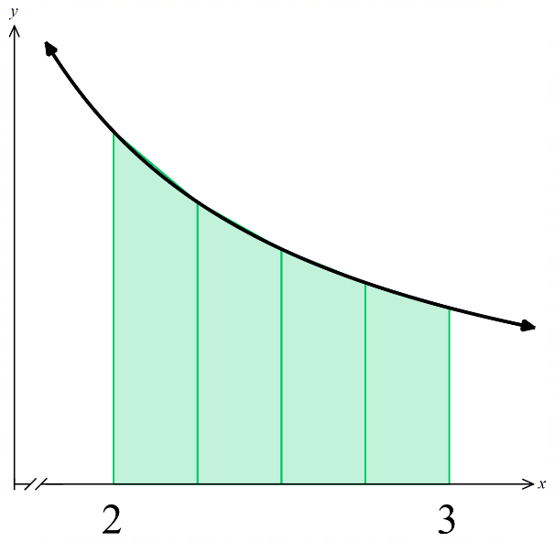
The height of each trapezium is
$$h=\frac{b-a}{n}=\frac{1}{4}=0.25$$
$$x$$ | 2 | 2.25 | 2.5 | 2.75 | 3
$$f\left(x\right)$$ | 2 | 1.6 | 1.3333 | 1.1428 | 1

$$\int_{2}^{3}{\left(\frac{2}{x-1}\right)}dx≈\frac{0.25}{2}\left(f\left(2\right)+f\left(3\right)+2(f\left(2.25\right)+f\left(2.5\right)+f\left(2.75\right)\right)$$
$$≈0.125\left(2+1+2(1.6+1.3333+1.1428\right)$$
$$≈1.394$$

- Guided Practice
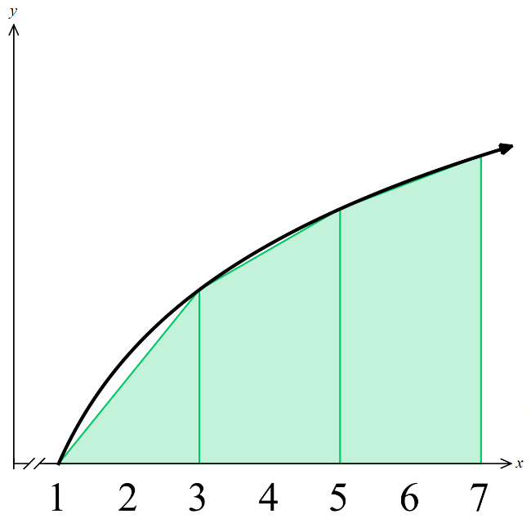
- Use trapezoidal rule with 3 subintervals to find an approximation to 3 d.p.
$$\int_{1}^{7}{\left(3\ln{x}\right)}dx$$
The height of each trapezium is …………………

$$x$$ | 1 |  |  | 7
$$f\left(x\right)$$

$$\int_{a}^{b}{f\left(x\right)}dx≈\frac{h}{2}\left[f\left(a\right)+f\left(b\right)+2(f\left(x_{1}\right)+…f\left(x_{n-1}\right)\right]$$

$22.086$ vs actual 22.864
- Use trapezoidal rule with 4 subintervals to find an approximation to 3 d.p.
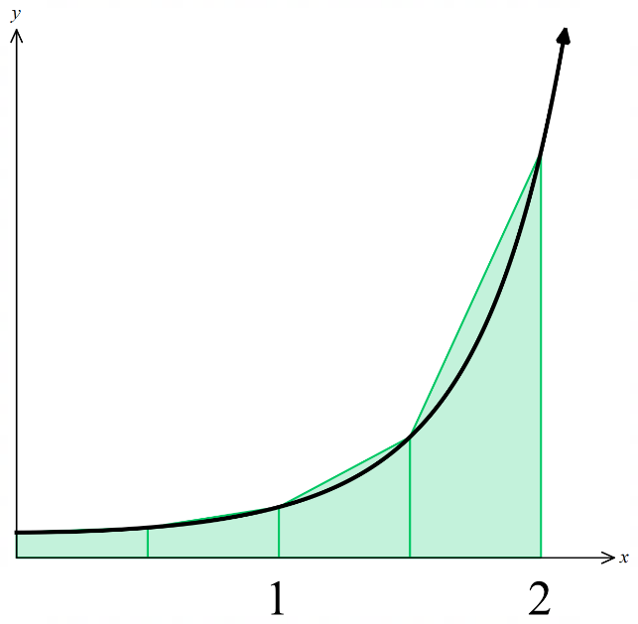
$$\int_{0}^{2}{\left(2^{x^{2}}\right)}dx$$

8.223 vs actual 7.340

- Accuracy of Trapezoidal Rule
The more intervals you use, the more accurate the estimate.
If the curve is concave up in the region, the trapezoidal rule overestimates the integral.
If the curve is concave down in the region, the trapezoidal rule underestimates the integral.
If the curve is linear, the trapezoidal rule gives the exact value of the integral.

Foundation
- Approximate $\int_{2}^{6}{ f\left(x\right)}dx$ using the formula $\frac{h}{2}\left(a + b\right)$ for the area of a trapezium.
$$A = \left(\frac{1}{2}\right)\left(8 + 12\right)\left(4\right)= 40$$ | $$A = \left(\frac{1}{2}\right)\left(6.2 + 4.8\right)\left(4\right)= 22$$ | $$A = \left(\frac{1}{2}\right)\left(-4 + \left(-9\right)\right)\left(4\right)= -26$$
  $$x$$ | 2 | 6
  $$f(x)$$ | 8 | 12
  $$x$$ | 2 | 6
  $$f(x)$$ | 6.2 | 4.8
  $$x$$ | 2 | 6
  $$f(x)$$ | −4 | −9

- Three function values are given in the table.
$$x$$ | 2 | 6 | 10
$$f(x)$$ | 12 | 20 | 30

  - Approximate $\int_{2}^{10}{ f\left(x\right)}dx$ by calculating the areas of two trapezia and then adding.
$$First trapezium: \left(\frac{1}{2}\right)\left(12 + 20\right)\left(4\right)= 64$$
$$Second trapezium: \left(\frac{1}{2}\right)\left(20 + 30\right)\left(4\right)= 100$$
$$Total = 164$$
  - Check your answer to part a by using the formula for the trapezoidal rule.
$h = 4$, using formula:
$$A ≈ \left(\frac{4}{2}\right)\left(12 + 2\left(20\right)+ 30\right)=164$$
- Use the trapezoidal rule with the three given function values to approximate $\int_{-5}^{5}{ f\left(x\right)}dx.$
$$x$$ | −5 | 0 | 5
$$f(x)$$ | 2.4 | 2.6 | 4.4
$$h = 5$$
$$A ≈ \left(\frac{5}{2}\right)\left(2.4 + 2\left(2.6\right)+ 4.4\right)= \left(\frac{5}{2}\right)\left(12\right)= 30$$
- Use the trapezoidal rule to find the approximate area of each irregular figure.
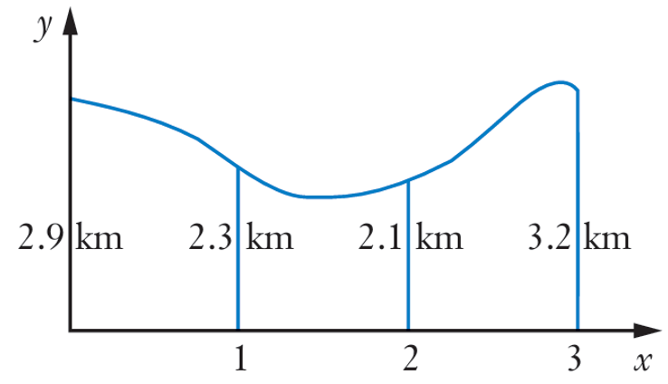  $7.45$ m² | 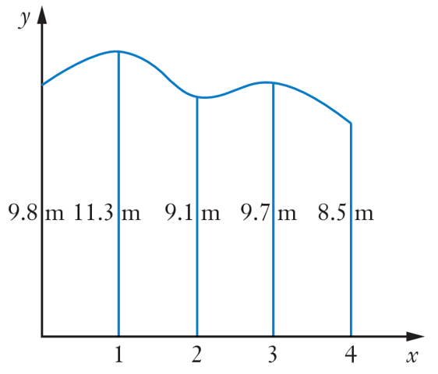  $39.25$ m²

  - Complete this table for the function $y = x(4 - x)$.
$$x$$ | 0 | 1 | 2 | 3 | 4
$$y$$
  - Hence use the trapezoidal rule with five function values to approximate$\int_{0}^{4}{ x\left(4 - x\right)}dx.$
$$h = 1$$
$$A ≈ \left(\frac{1}{2}\right)\left(0 + 2(3+4+3)+ 0\right)= 10$$
  - What is the exact value of $\int_{0}^{4}{ x\left(4 - x\right)}dx$, and why does it exceed the approximation? Sketch the curve and the four trapeziums involved.
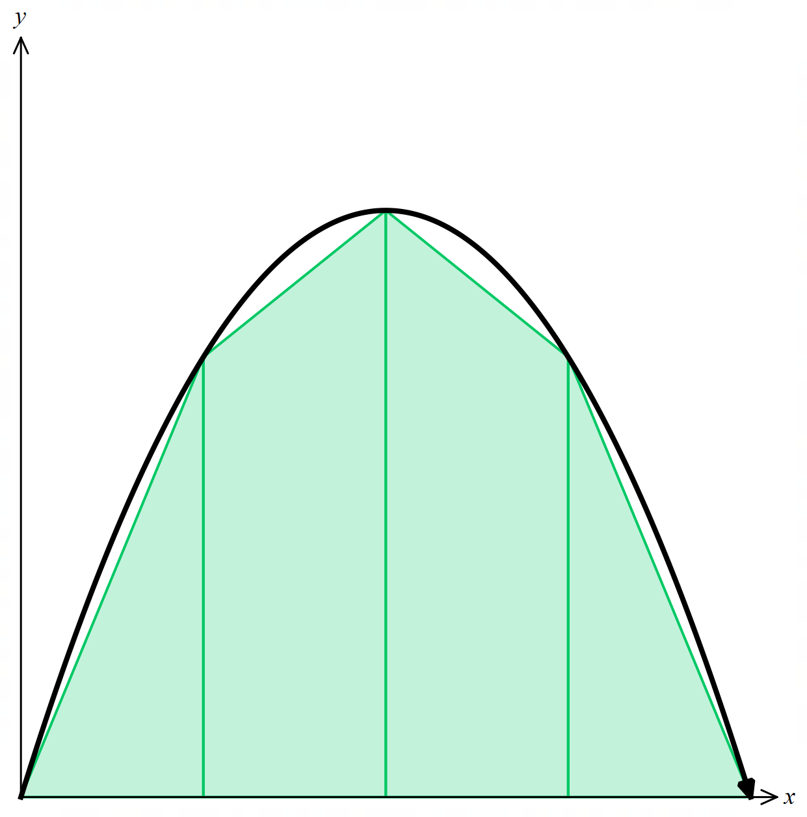
$$\int_{0}^{4}{ \left(4x - x^{2}\right)}dx$$
$$= {\left[2x^{2}-\frac{x^{3}}{3}\right]}_{0}^{4}$$
$$= 32 -\frac{64}{3}$$
$$= 10\frac{2}{3}$$
The curve $y = x(4 - x)$ is a concave down parabola (you can also check second derivative).
The chords lie below the curve, so the trapezoidal approximation underestimates the integral.

  - Complete this table for the function $y =$ $\frac{6}{x}$.
$$x$$ | 1 | 2 | 3 | 4 | 5
$$y$$
  - Use the trapezoidal rule with the five function values above, that is with four subintervals, to approximate $\int_{1}^{5}{\frac{6}{x}}$ $dx$.
$$h = 1$$
$$A ≈ \left(\frac{1}{2}\right)\left(6 + 2\left(3+2+\frac{3}{2}\right)+\frac{6}{5}\right)$$
$$=\frac{101}{10}$$
  - Show that the second derivative of $y =$ $\frac{6}{x}$ is $y″ = 12x^{-3},$ and use this result to explain why the approximation will exceed the exact value of the integral.
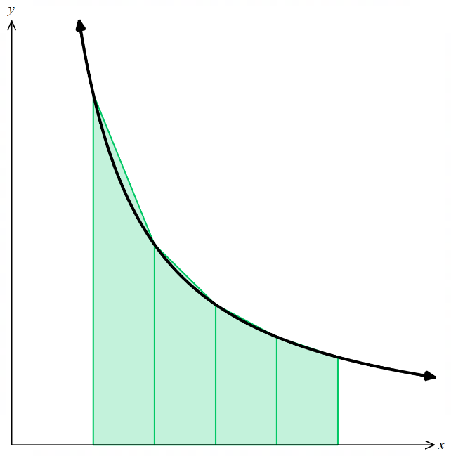

$$y = 6x^{-1}$$
$$y^{'}= -6x^{-2}$$
$$y″ = 12x^{-3}$$
For $x > 0, y″ > 0$, so the curve is concave up on [1, 5].
The chords lie above the curve, so the trapezoidal approximation overestimates the integral.

Development

  - Complete this table correct to four decimal places for the function $y = \sqrt{x}$.
$$x$$ | 9 | 10 | 11 | 12 | 13 | 14 | 15 | 16
$$y$$

  - Approximate $\int_{9}^{16}{ \sqrt{x}}dx$, using the trapezoidal rule with the eight function values above. Give your answer correct to three significant figures.

$$h = 1$$
$$A ≈ \left(\frac{1}{2}\right)\left(3 + 2\left(3.1623+3.3166+3.4641+3.6056+3.7417+3.8730\right)+ 4\right)$$
$$≈ 24.7 (3 s.f.)$$
  - What is the exact value of $\int_{9}^{16}{ \sqrt{x}}dx$?
$$\int_{9}^{16}{ \sqrt{x}}dx = \int_{9}^{16}{ x^{\frac{1}{2}}}dx = {\left[\left(\frac{2}{3}\right)x^{\frac{3}{2}}\right]}_{9}^{16}$$
$$= \left(\frac{2}{3}\right)\left(64 - 27\right)$$
$$= 24\frac{2}{3}$$
  - Show that the second derivative of $y = x^{\frac{1}{2}}$ is $y″ = -\left(\frac{1}{4}\right)x^{-\frac{3}{2}}$, and use this result to explain why the approximation is less than the value of the definite integral.
$$y = x^{\frac{1}{2}}$$
$$y' = \left(\frac{1}{2}\right)x^{-\frac{1}{2}}$$
$$y″ = -\left(\frac{1}{4}\right)x^{-\frac{3}{2}}$$
For $x > 0, y″ < 0$, so the curve is concave down on [9, 16].
The chords lie below the curve, so the trapezoidal approximation is less than the exact value.

- Use the trapezoidal rule with five function values to approximate each definite integral, writing your answer correct to three significant figures where necessary.
- $\int_{2}^{6}{ \left(\frac{1}{x}\right)}dx$  $$≈ 1.12 (3 s.f.)$$ | - $\int_{0}^{2}{\frac{1}{2 + \sqrt{x}}}dx$  ≈ 0.705 (3 s.f.)
- $\int_{4}^{8}{ \sqrt{x^{2}- 3}}dx$  $$≈ 22.9 (3 s.f.)$$ | - $\int_{1}^{2}{log_{10}x }dx$  $$≈ 0.167 (3 s.f.)$$
- An object is moving along the $x$-axis with values of the velocity $v$ in m/s at various times $t$ given in the table.
$$t$$ | 0 | 1 | 2 | 3 | 4 | 5
$$v$$ | 1.5 | 1.3 | 1.4 | 2.0 | 2.4 | 2.7
Given that the distance travelled may be found by calculating the area under the velocity/time graph, use the trapezoidal rule to estimate the distance travelled by the particle in the first 5 seconds.

$$h = 1$$
$$Distance ≈ \left(\frac{1}{2}\right)\left(1.5 + 2\left(1.3+1.4+2.0+2.4\right)+ 2.7\right)$$
= 9.2 metres
- The diagram to the right shows the width of a lake at 10-metre intervals.
Use the trapezoidal rule to estimate the surface area of the water.
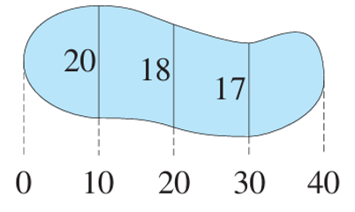

$h = 10$, widths at $x = 0, 10, 20, 30, 40: 0, 20, 18, 17, 0$
$$A ≈ \left(\frac{10}{2}\right)\left(0 + 2\left(20\right)+ 2\left(18\right)+ 2\left(17\right)+ 0\right)= 5\left(110\right)= 550 m^{2}$$

- The diagram shows a vertical rock cutting of length 300 metres alongside a straight horizontal section of highway. The heights of the cutting are measured at 50-metre intervals. Use the trapezoidal rule to estimate the area of the vertical rock cutting.
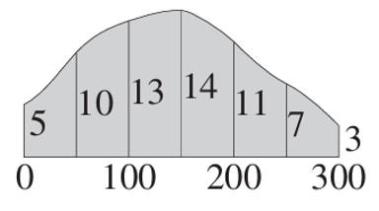
$A ≈\frac{50}{2}\left(5 + 2\left(10 + 13+ 14 + 11 + 7\right)+ 3\right) m^{2}$
$=2950$ m²

  - Use the trapezoidal rule with five function values to approximate $\int_{0}^{1}{ \sqrt{1 - x^{2}}}dx$, giving your answer correct to four decimal places.

$$A ≈ 0.7489 \left(4 d.p.\right)$$
  - Use part a and the fact that $y = \sqrt{1 - x^{2}}$ is a semi-circle to approximate $π$. Give your answer correct to one decimal place, and explain why your approximation is less than $π$.
$y = \sqrt{1 - x^{2}}$ is the upper half of the unit circle $x² + y² = 1.$
So $A≈0.7489$represents one quarter of a unit circle: $\frac{1}{4}$ $π{\left(1\right)}^{2}$
So $π ≈ 4 × 0.7489 ≈ 3.0$ (1 d.p.)
Since the semicircle is concave down, the approximation is less than $π$

Area under Exponential, Reciprocal, and Trigonometric Curves

Foundation

  - Find the area of the region bounded by the curve $y = e^{\frac{x}{2}}$, the $x$-axis,
and the lines $x=-1$ and $x=2$.
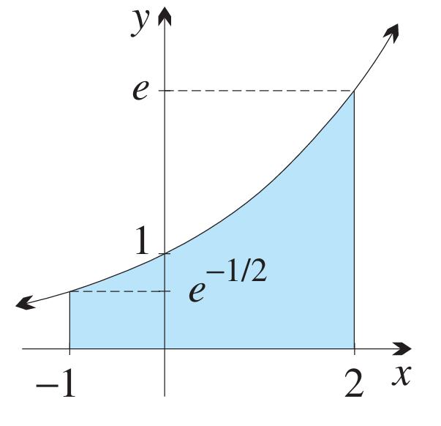

$$\int_{-1}^{2}{e^{\frac{x}{2}}}dx = {\left[2e^{\frac{x}{2}}\right]}_{-1}^{2}$$
$$= 2e - 2e^{-\frac{1}{2}} u^{2}$$
  - Find the area of the region bounded by the curve $y = e^{-x},$ the $x$-axis,
the $y$-axis and the line $x=1$.
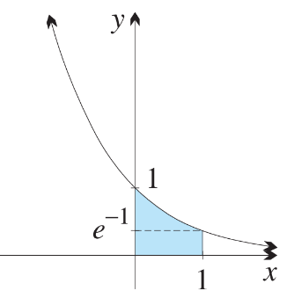

$$\int_{0}^{1}{e^{-x}}dx = {\left[-e^{-x}\right]}_{0}^{1}$$
$$= -e^{-1}+ 1$$
$$= \left(1 - e^{-1}\right) u^{2}$$

  - Find the area of the shaded region under $y =\frac{1}{x}$ from $x=2$ to $x=3$.
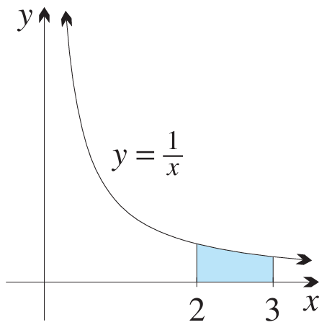

$$\int_{2}^{3}{\left(\frac{1}{x}\right)}dx = {\left[ln x\right]}_{2}^{3}$$
$$= ln 3 - ln 2 u^{2}$$
  - Find the area of the shaded region under $y =\frac{1}{x}$ from $x=\frac{1}{2}$ to $x=2$.
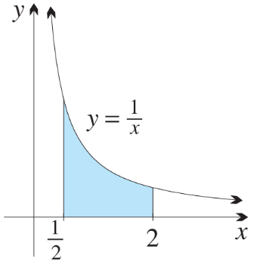

$$\int_{\frac{1}{2}}^{2}{\left(\frac{1}{x}\right)}dx = {\left[ln x\right]}_{\frac{1}{2}}^{2}$$
$$=\ln{2}- ln\left(\frac{1}{2}\right)$$
$$= 2 ln 2 u^{2}$$

  - Find the area of the region in the first quadrant bounded by the coordinate axes and the curve $y=e-e^{x}$.
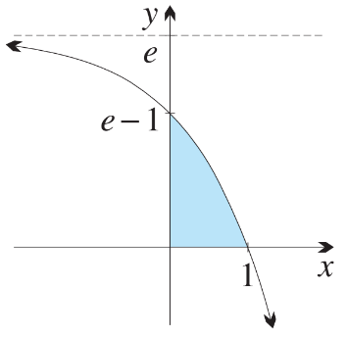

$$\int_{0}^{1}{\left(e - eˣ\right)}dx = {\left[ex - eˣ\right]}_{0}^{1}$$
$$= \left(e - e\right)- \left(0 - 1\right)$$
$$= 1 u^{2}$$
  - Find the area between the $x$-axis, the curve $y = eˣ - 1$ and the line $x = -1$.
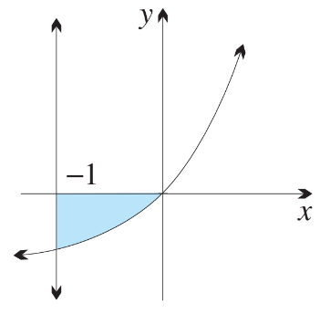

$$-\int_{-1}^{0}{\left(e^{x} - 1\right)}dx = -{\left[e^{x}-x\right]}_{-1}^{0}$$
$$= -\left[\left(1\right)- \left(e^{-1}+ 1\right)\right]$$
$$= e^{-1} u^{2}$$
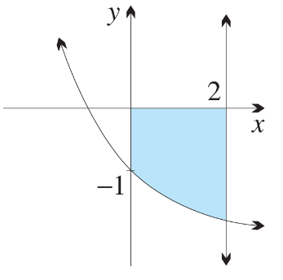
  - What is the area bounded by $x = 2, y = e^{-x}- 2$, the $x$-axis and the $y$-axis?

$$-\int_{0}^{2}{\left(e^{-x}-2\right)}dx=-{\left[-e^{-x}- 2x\right]}_{0}^{2}$$
$$= -\left[\left(-e^{-2}- 4\right)- \left(-1\right)\right]$$
$$= \left(3 + e^{-2}\right) u^{2}$$
  - Find the area of the region bounded by the curve $y = e^{-x}- e$ and the coordinate axes.
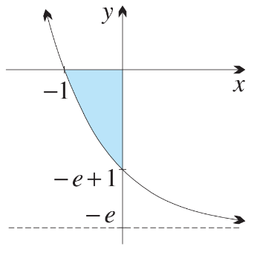

$$-\int_{-1}^{0}{\left(e^{-x}- e\right)}dx = -{\left[-e^{-x}- ex\right]}_{-1}^{0}$$
$$= -\left[\left(-1\right)- \left(-e + e\right)\right]$$
$$= 1 u^{2}$$
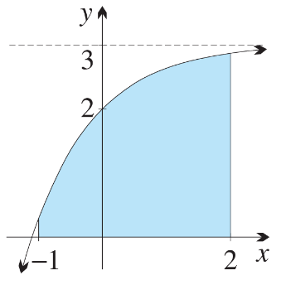
  - Find the area of the region bounded by the curve $y = 3 - e^{-x}$, the $x$-axis, and the lines $x=-1$ and $x=2$.

$$\int_{-1}^{2}{\left(3 - e^{-x}\right)}dx = {\left[3x + e^{-x}\right]}_{-1}^{2}$$
$$= \left(6 + e^{-2}\right)- \left(-3 + e\right)$$
$$= \left(9 + e^{-2}- e\right) u^{2}$$

  - Calculate the area of the shaded region between $y = sin x$ and the $x$-axis from $x =\frac{π}{6}$ to $x = π$.
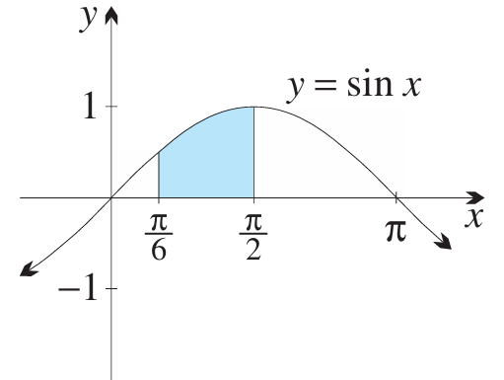

$$\int_{\frac{π}{6}}^{\frac{π}{2}}{sin}x dx = {\left[-cos x\right]}_{\frac{π}{6}}^{\frac{π}{2}}$$
$$= 0 +\frac{\sqrt{3}}{2}$$
$$= \left(\frac{1}{2}\right)\sqrt{3}u^{2}$$
  - Calculate the area of the shaded region between $y = cos x$ and the $x$-axis from $x =\frac{π}{2}$ to $x = π$.
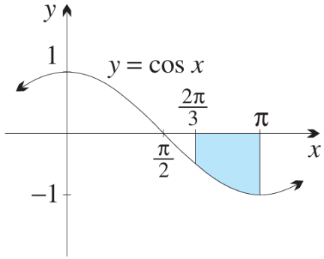

$$-\int_{\frac{2π}{3}}^{π}{cos}x dx = -{\left[sin x\right]}_{\frac{2π}{3}}^{π}$$
$$= -\left(0 -\frac{\sqrt{3}}{2}\right)$$
$$= \left(\frac{1}{2}\right)\sqrt{3}u^{2}$$

  - Find the area between the curve $y= e^{x}+e^{-x}$ and the $x$-axis, from $x=-2$ to $x=2$.

$$eˣ + e^{-x}> 0 for all x.$$
$$Area = \int_{-2}^{2}{\left(eˣ + e^{-x}\right)}dx = {\left[eˣ - e^{-x}\right]}_{-2}^{2}$$
$$= \left(e^{2}- e^{-2}\right)- \left(e^{-2}- e^{2}\right)$$
$$= 2\left(e^{2}- e^{-2}\right)$$
$$≑ 14.51 u^{2}$$
  - Find the area between the curve $y=x²+eˣ$ and the $x$-axis, from $x = -3$ to $x = 3$.

$$x² + eˣ > 0 for all x.$$
$$Area = \int_{-3}^{3}{\left(x^{2}+ eˣ\right)}dx = {\left[\frac{x^{3}}{3}+ eˣ\right]}_{-3}^{3}$$
$$= \left(9 + e^{3}\right)- \left(-9 + e^{-3}\right)$$
$$= 18 + e^{3}- e^{-3}$$
$$≑ 38.04 u^{2}$$

  - Find the area enclosed between $y = sin x$ and the $x$-axis over $x =\frac{π}{3}$ to $x =\frac{π}{2}$.
$$\int_{\frac{π}{3}}^{\frac{π}{2}}{sin}x dx = {\left[-cos x\right]}_{\frac{π}{3}}^{\frac{π}{2}}$$
$$= 0 +\frac{1}{2}$$
$$=\frac{1}{2}u^{2}$$

  - Find the area enclosed between $y = sin 2x$ and the $x$-axis over $x =\frac{π}{4}$ to $x =\frac{π}{2}.$
$$\int_{\frac{π}{4}}^{\frac{π}{2}}{sin}2x dx = {\left[-\left(\frac{1}{2}\right)cos 2x\right]}_{\frac{π}{4}}^{\frac{π}{2}}$$
$$= \left(\frac{1}{2}\right)+ 0$$
$$=\frac{1}{2}u^{2}$$

  - Find the area enclosed between $y = cos x$ and the $x$-axis over $x =\frac{π}{3}$ to $x =\frac{π}{2}$.
$$\int_{\frac{π}{3}}^{\frac{π}{2}}{cos}x dx = {\left[sin x\right]}_{\frac{π}{3}}^{\frac{π}{2}}= 1 -\frac{\sqrt{3}}{2}$$
$$= \left(\frac{1}{2}\right)\left(2 - \sqrt{3}\right) u^{2}$$

  - Find the area enclosed between $y = cos 3x$ and the $x$-axis over $x =\frac{π}{12}$ to $x =\frac{π}{6}$.
$$\int_{\frac{π}{12}}^{\frac{π}{6}}{cos}3x dx = {\left[\left(\frac{1}{3}\right)sin 3x\right]}_{\frac{π}{12}}^{\frac{π}{6}}$$
$$= \left(\frac{1}{3}\right)\left(sin\left(\frac{π}{2}\right)- sin\left(\frac{π}{4}\right)\right)$$
$$= \left(\frac{1}{6}\right)\left(2 - \sqrt{2}\right)u^{2}$$

  - Find the area enclosed between $y = sec² x$ and the $x$-axis over$x =\frac{π}{6}$ to $x =\frac{π}{3}.$
$$\int_{\frac{π}{6}}^{\frac{π}{3}}{sec^{2}x} dx = {\left[tan x\right]}_{\frac{π}{6}}^{\frac{π}{3}}$$
$$= \sqrt{3}-\frac{1}{\sqrt{3}}$$
$$= \left(\frac{2}{3}\right)\sqrt{3}u^{2}$$

  - Find the area enclosed between $y = \sec^{2}\left(\frac{x}{2}\right)$ and the $x$-axis over $x = -\frac{π}{2}$ to$x =\frac{π}{2}$.
$$\int_{-\frac{π}{2}}^{\frac{π}{2}}{sec^{2}\left(\frac{x}{2}\right)}dx = {\left[2 tan\left(\frac{x}{2}\right)\right]}_{-\frac{π}{2}}^{\frac{π}{2}}$$
$$= 2\left(1\right)- 2\left(-1\right)$$
$$= 4 u^{2}$$

Development

  - Find the area between $y =\frac{1}{3x + 2}$ and the $x$-axis for $0 ≤ x ≤ 1$.

$$\int_{0}^{1}{\frac{1}{3x + 2}} dx = {\left[\left(\frac{1}{3}\right)ln\left(3x + 2\right)\right]}_{0}^{1}$$
$$= \left(\frac{1}{3}\right)\left(ln 5 - ln 2\right) u^{2}$$
  - Find the area between $y =\frac{3}{x - 1}$ and the $x$-axis for $2 ≤ x ≤ e³ + 1$.

$$\int_{2}^{e^{3}+1}{\frac{3}{x - 1}} dx = {\left[3 ln\left(x - 1\right)\right]}_{2}^{e^{3}+1}$$
$$= 3\ln{e^{3}}- 3\ln{1}$$
$$= 9 u^{2}$$
  - Find the area between $y =\frac{1}{x}+ x$ and the $x$-axis, from $x =\frac{1}{2}$ to $x = 2$.
$$\int_{\frac{1}{2}}^{2}{\left(\frac{1}{x}+ x\right)}dx = \left[ln x +\frac{x^{2}}{2}\right]{\left(\frac{1}{2}\right)}^{2}$$
$$= \left(ln 2 + 2\right)- \left(-ln 2 +\frac{1}{8}\right)$$
$$= 2 ln 2 +\frac{15}{8}u^{2}$$
  - Find the area between $y =\frac{1}{x}+ x^{2}$ and the $x$-axis, from $x = 1$ to $x = 3$.
$$\int_{1}^{3}{\left(\frac{1}{x}+ x^{2}\right)}dx = {\left[ln x +\frac{x^{3}}{3}\right]}_{1}^{3}$$
$$= \left(ln 3 + 9\right)- \left(0 +\frac{1}{3}\right)$$
$$= ln 3 +\frac{26}{3}u^{2}$$

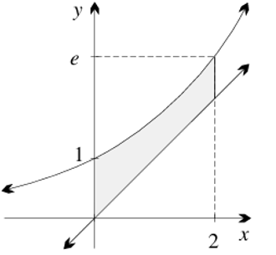
  - Sketch the region between the graphs of $y=e^{x}$ and $y=x$, between the $y$-axis and
$x=2$, then find its area.
$$On \left[0, 2\right], eˣ ≥ x.$$
$$Area = \int_{0}^{2}{\left(eˣ - x\right)}dx = {\left[eˣ -\frac{x^{2}}{2}\right]}_{0}^{2}$$
$$= \left(e^{2}- 2\right)- 1$$
$$= \left(e^{2}- 3\right)u^{2}$$

  - Find the intercepts of the curve $y = 8 - 2^{x}$ and hence find the area of the region bounded by this curve and the coordinate axes.
$x$-intercept: $8 - 2ˣ = 0$, so $2ˣ = 8, x = 3$. $y$-intercept: $x = 0, y = 7.$
Intercepts: (0, 7) and (3, 0).
$$Area = \int_{0}^{3}{\left(8 - 2ˣ\right)}dx = {\left[8x -\frac{2ˣ}{\ln{2}}\right]}_{0}^{3}$$
$$= \left(24 -\frac{8}{\ln{2}}\right)- \left(0 -\frac{1}{\ln{2}}\right)$$
$$= 24 -\frac{7}{\ln{2}} u²$$

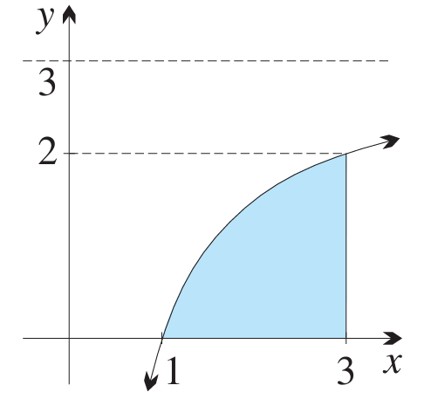
  - Find the area of the region bounded by $y = 3 -\frac{3}{x}$, the $x$-axis and $x = 3$.

$$\int_{1}^{3}{\left(3 -\frac{3}{x}\right)}dx = {\left[3x - 3 ln x\right]}_{1}^{3}$$
$$= \left(9 - 3 ln 3\right)- 3$$
$$= \left(6 - 3 ln 3\right) u^{2}$$
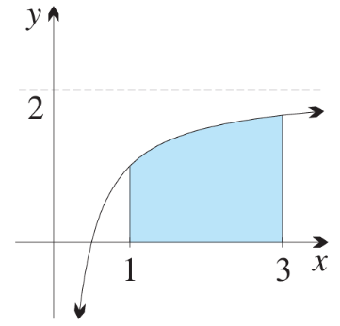
  - Find the area of the region bounded by $y = 2 -\frac{1}{x}$, the $x$-axis, $x = 1$ and $x = 3$.

$$\int_{1}^{3}{\left(2 -\frac{1}{x}\right)}dx = {\left[2x -\ln{x}\right]}_{1}^{3}$$
$$= \left(6 -\ln{3}\right)- 2$$
$$= (4 - ln 3) u²$$

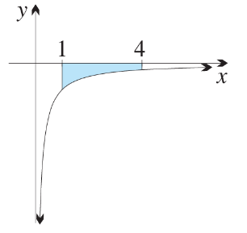
  - Find the area of the region bounded by $y = -\frac{1}{x}$, the $x$-axis, $x = 1$ and $x = 4$.

$$\int_{1}^{4}{\left(\frac{1}{x}\right)}dx = {\left[ln x\right]}_{1}^{4}$$
$$= ln 4 u^{2}$$

  - Find the area of the region bounded by $y =\frac{3}{x}- 3$, the $x$-axis and $x = 3$.
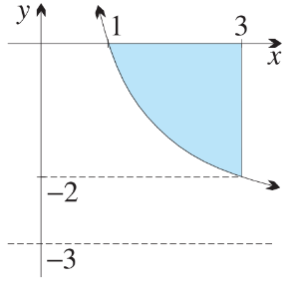

$$-\int_{1}^{3}{\left(\frac{3}{x}- 3\right)}dx = -{\left[3 ln x - 3x\right]}_{1}^{3}$$
$$= -\left[\left(3 ln 3 - 9\right)- \left(-3\right)\right]$$
$$= \left(6 - 3 ln 3\right) u²$$

- Calculate the area of the shaded region.
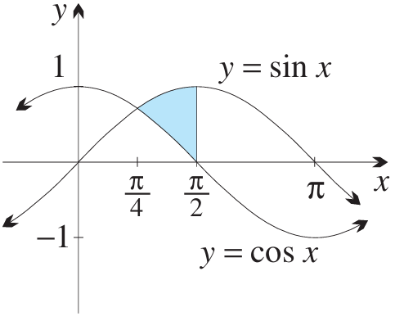

$$\int_{0}^{\frac{π}{2}}{\left(x - sin x\right)}dx = {\left[\frac{x^{2}}{2}+ cos x\right]}_{0}^{\frac{π}{2}}$$
$$= \left(\frac{π^{2}}{8}+ 0\right)- \left(0 + 1\right)$$
$$= \left(\frac{π^{2}}{8}- 1\right)u^{2}$$
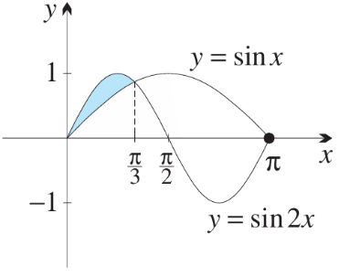

$$\int_{-\frac{π}{2}}^{\frac{π}{2}}{\left(1 - cos x\right)}dx = {\left[x - sin x\right]}_{-\frac{π}{2}}^{\frac{π}{2}}$$
$$= \left(\frac{π}{2}- 1\right)- \left(-\frac{π}{2}+ 1\right)$$
$$= \left(π - 2\right) u^{2}$$
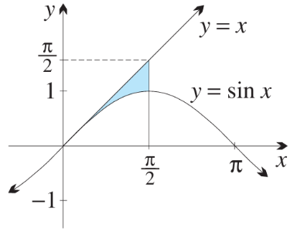

$$\int_{0}^{\frac{π}{4}}{\left(cos x - sin x\right)}dx + \int_{\frac{π}{4}}^{π}{\left(sin x - cos x\right)}dx$$
$$= {\left[sin x + cos x\right]}_{0}^{\frac{π}{4}}+ {\left[-cos x - sin x\right]}_{\frac{π}{4}}^{π}$$
$$= \left(\sqrt{2}- 1\right)+ \left(1 + \sqrt{2}\right)$$
$$= 2\sqrt{2} u^{2}$$
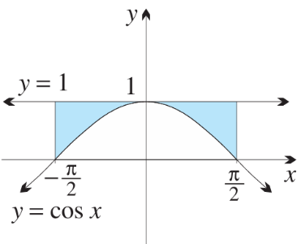
$$\int_{-\frac{π}{2}}^{0}{\left(cos x - x - 1\right)}dx + \int_{0}^{\frac{π}{2}}{\left(x + 1 - cos x\right)}dx$$
$$= {\left[sin x -\frac{x^{2}}{2}- x\right]}_{-\frac{π}{2}}^{0}+ {\left[\frac{x^{2}}{2}+ x - sin x\right]}_{0}^{\frac{π}{2}}$$
$$= \left(0 - \left(-1 -\frac{π^{2}}{8}+\frac{π}{2}\right)\right)+ \left(\frac{π^{2}}{8}+\frac{π}{2}- 1\right)$$
$$=\frac{π^{2}}{4}u^{2}$$
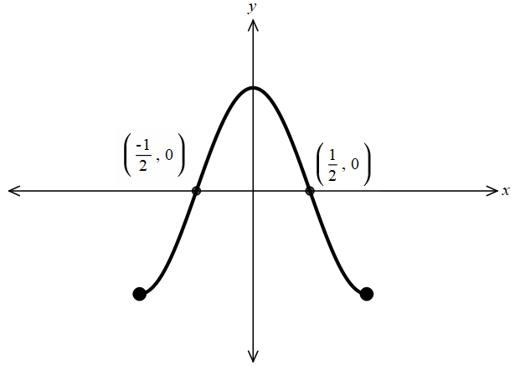
  - Sketch the curve $y = 2 cos πx$, for −$1 ≤ x ≤ 1$,
clearly marking the two $x$-intercepts.

  - Find the exact area bounded by the curve $y = 2 cos πx$ and
the $x$-axis, between the two $x$-intercepts.
$$\int_{-\frac{1}{2}}^{\frac{1}{2}}{2}\cos{πx} dx = {\left[\left(\frac{2}{π}\right)sin πx\right]}_{-\frac{1}{2}}^{\frac{1}{2}}$$
$$= \left(\frac{2}{π}\right)\left(1\right)- \left(\frac{2}{π}\right)\left(-1\right)=\frac{4}{π}u^{2}$$

  - Differentiate $x² + 1$, and hence find the area under the graph $y =\frac{x}{x^{2}+ 1},$ between $x = 0$ and $x = 2$.

$$\frac{d}{dx}\left(x^{2}+ 1\right)= 2x$$
$$so \int{\frac{x}{x^{2}+ 1}} dx = \left(\frac{1}{2}\right)ln\left(x^{2}+ 1\right)+ C.$$
$$Area = {\left[\left(\frac{1}{2}\right)ln\left(x^{2}+ 1\right)\right]}_{0}^{2}= \left(\frac{1}{2}\right)ln 5 ≑ 0.805 u^{2}$$
  - Differentiate $x² + 2x + 3$, and hence find the area under the graph $y =\frac{x + 1}{x^{2}+ 2x + 3},$ between $x = 0$ and $x = 1$.
$$\frac{d}{dx}\left(x^{2}+ 2x + 3\right)= 2\left(x + 1\right),$$
$$so \int{\frac{x + 1}{x^{2}+ 2x + 3}} dx = \left(\frac{1}{2}\right)ln\left(x^{2}+ 2x + 3\right)+ C.$$
$$Area = {\left[\left(\frac{1}{2}\right)ln\left(x^{2}+ 2x + 3\right)\right]}_{0}^{1}$$
$$=\left(\frac{1}{2}\right)\ln{6}-\left(\frac{1}{2}\right)\ln{3}$$
$$= \left(\frac{1}{2}\right)ln 2 u^{2}$$

- Draw a rough sketch of the area enclosed between each curve and the x-axis over the specified domain, and then find the exact value of the area. (Make use of symmetry wherever possible.)
  - $y = cos x$, from $x = 0$to $x = π$
$$2\int_{0}^{\frac{π}{2}}{cos}x dx = 2{\left[sin x\right]}_{0}^{\frac{π}{2}}$$
$= 2 u^{2}$
  - $y = sin x,$ from $x =\frac{π}{4}$ to $x =\frac{3π}{4}$
$$\int_{\frac{π}{4}}^{\frac{3π}{4}}{sin}x dx = {\left[-cos x\right]}_{\frac{π}{4}}^{\frac{3π}{4}}$$
$$=\frac{\sqrt{2}}{2}+\frac{\sqrt{2}}{2}$$
$$= \sqrt{2} u^{2}$$
  - $y = cos 2x,$ from $x = 0$ to $x = π$
Four half-arches of equal area
$$4\int_{0}^{\frac{π}{4}}{cos}2x dx = 4{\left[\left(\frac{1}{2}\right)sin 2x\right]}_{0}^{\frac{π}{4}}$$
$$= 4\left(\frac{1}{2}\right)$$
$$= 2 u^{2}$$
  - $y = sin 2x$, from $x =\frac{π}{3}$ to $x =\frac{2π}{3}$
By symmetry about $x =\frac{π}{2}:$
$2\int_{\frac{π}{3}}^{\frac{π}{2}}{sin}2x dx = 2{\left[-\left(\frac{1}{2}\right)cos 2x\right]}_{\frac{π}{3}}^{\frac{π}{2}}= \frac{1}{2} u^{2}$

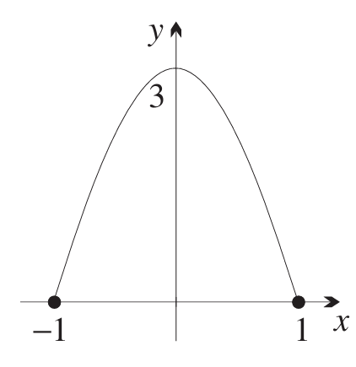
- An arch window 3 metres high and 2 metres wide is made in the shape of the curve
$y = 3 cos\left(\frac{πx}{2}\right)$. Find the area of the window in square metres, correct to one decimal place.

$$\int_{-1}^{1}{3}cos\left(\frac{πx}{2}\right) dx = {\left[\left(\frac{6}{π}\right)sin\left(\frac{πx}{2}\right)\right]}_{-1}^{1}$$
$$= \left(\frac{6}{π}\right)\left(1\right)- \left(\frac{6}{π}\right)\left(-1\right)$$
$$=\frac{12}{π}≑ 3.8 m^{2}$$

- The region $R$ is bounded by the curve $y = tan x$, the $x$-axis and the vertical line $x =\frac{π}{3}$.
Show that $R$ has area ln 2 square units.

$$\int_{0}^{\frac{π}{3}}{tan}x dx = {\left[-ln\left(cos x\right)\right]}_{0}^{\frac{π}{3}}$$
$$= -ln\left(\frac{1}{2}\right)+\ln{1}$$
$$= ln 2 u^{2}$$

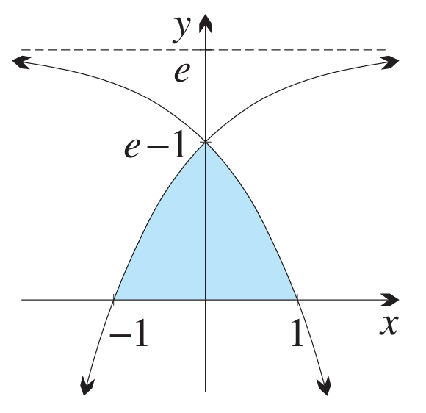
- The diagram shows the region above the $x$-axis,
below both $y = e - e^{-x}$ and $y = e - e^{x}$.
  - Explain why the area of this region
may be written as area $= 2\int_{0}^{1}{\left(e - eˣ\right)dx}$.

The curves $y = e - e^{-x}$ and $y = e - eˣ$ are reflections of each other in the $y$-axis (swapping $x$ with $-x$ swaps the two curves).
For $x ∈ [0, 1],$ the region above the x-axis lies below $y = e - eˣ$ (which reaches 0 at $x = 1$). By symmetry, area = $2\int_{0}^{1}{\left(e - eˣ\right)}dx$.
  - Hence find the area of this region.

$$2{\left[ex - eˣ\right]}_{0}^{1}= 2\left[\left(e - e\right)- \left(0 - 1\right)\right]= 2 u^{2}$$

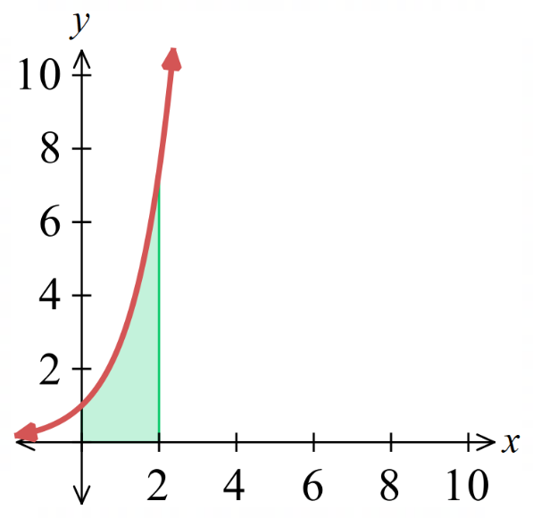
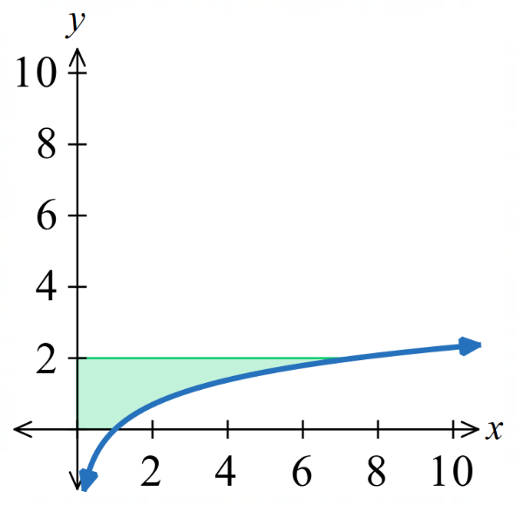
  - Consider the area $\int_{0}^{2}{\ln{x}}dy$ on the left.
Explain why this is equivalent to finding $\int_{0}^{2}{e^{x}}dx$ on the right.

$y=\ln{x}$ and $y=e^{x}$ are reflections of
each other across $y=x$.
So, the areas are equivalent.

  - Hence find $\int_{0}^{2}{\ln{x}}dy$.
$$\int_{0}^{2}{\ln{x}dy}=\int_{0}^{2}{e^{x}}dx$$
$$={\left[e^{x}\right]}_{0}^{2}$$
$=e^{2}-1$ $u^{2}$

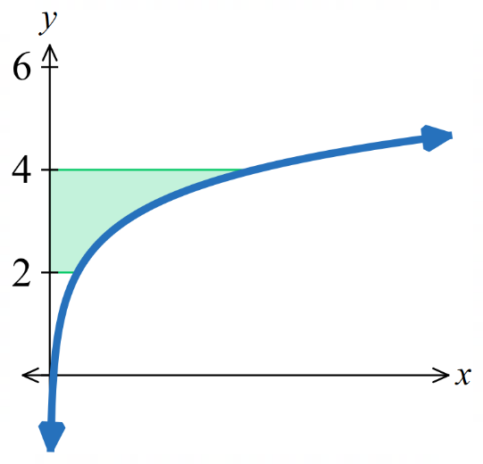
- Find the area between the curve $y=\ln{x}$, the $y$-axis and the lines $y=2$ and $y=4$.

$$A=\int_{2}^{4}{e^{x}}dx$$
$=e^{4}-e^{2}$ $u^{2}$
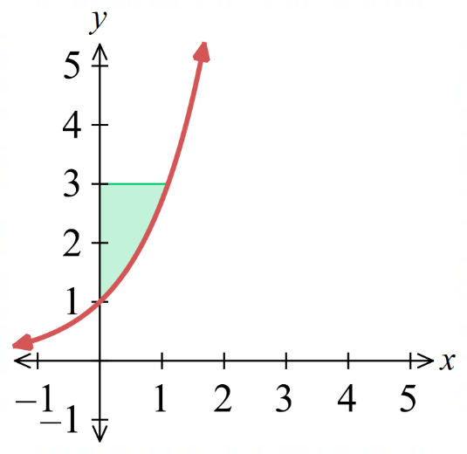
- Find the area between the curve $y=e^{x}$, the $y$-axis and the lines $y=1$ and $y=3$.
Hint: subtract the area under the curve from the bounding rectangle.
You will need to change the limits.

Change limits: $y=1;x=0$
$$y=3, x=\ln{3}$$
Bounding rectangle: $3×\ln{3}=3\ln{3}$
Area under curve: $A=\int_{0}^{\ln{3}}{e^{x}}dx=3-1=2$
Area required = $3\ln{3}-2$ $u^{2}$
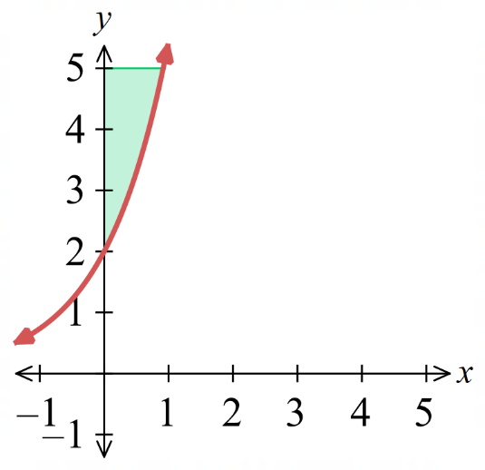
- Find the area between the curve $y=2e^{x}$, the $y$-axis, and the lines $y=3$ and $y=5$.

$$5\ln{\frac{5}{3}}-2 u^{2}$$
- Consider $\int_{1}^{3}{\ln{x}}dx$. We have no direct integration rule for $\ln{x}$.
Instead, use the fact that $y=\ln{x}$ and $y=e^{x}$ are reflections of each other across $y=x$.
This means $\int_{1}^{3}{\ln{x}}dx=\int_{1}^{3}{e^{x}}dy$. We can find the area under $y=e^{x}$ by integrating with respect to $x$, then subtracting this area from the bounding rectangle: $\int_{1}^{3}{e^{x}}dy=rectangle-\int_{\ln{1}}^{\ln{3}}{e^{x}}dx$
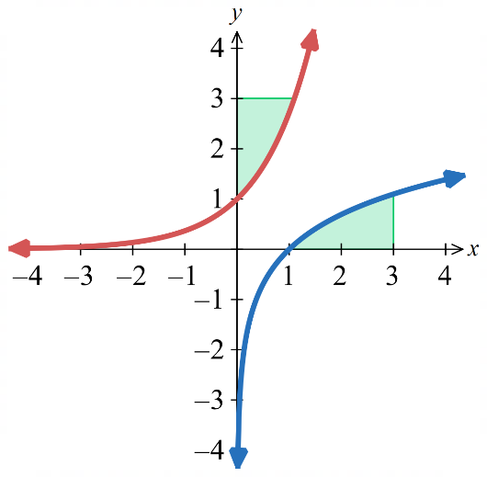
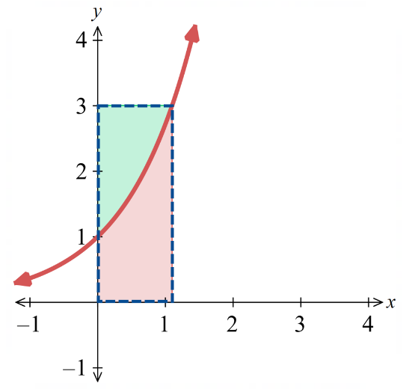
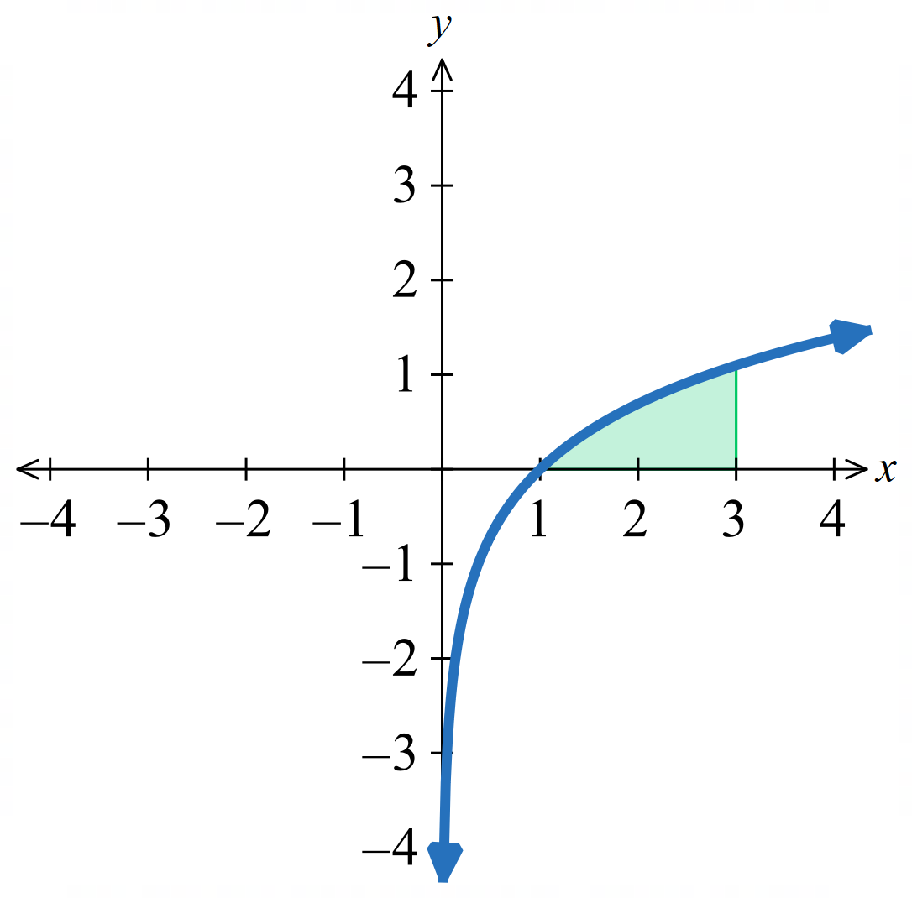

We will find the area bounded by $y=\ln{x}$, the $x$ axis, $x=1$ and $x=3$ by following these steps:
  - $\int_{1}^{3}{\ln{x}}dx≡\int_{1}^{3}{e^{x}}dy$. We also have no way of finding this directly. But we can find the area under the curve, first, change limits to in terms of $x$.
Show that the area under the curve is $\int_{0}^{\ln{3}}{e^{x}}dx$.
$$y=e^{x}, x=\ln{y}$$
$$y=1, x=\ln{1}=0$$
$$y=3, x=\ln{3}$$
  - Therefore, find the area under $y=e^{x}$ from $y=0$ to $y=\ln{3}$.
$$\int_{0}^{\ln{3}}{e^{x}}dx={\left[e^{x}\right]}_{0}^{\ln{3}}$$
$=3-1=2$ $u^{2}$
  - Calculate the area of the bounding rectangle with width $\ln{3}$ and height $3$.
$A_{rect}=3\ln{3}$ $u^{2}$
  - Therefore, find $\int_{1}^{3}{\ln{x}}dx$.
$$\int_{1}^{3}{\ln{x}}dx=rectangle-\int_{0}^{\ln{3}}{e^{x}}dx$$
$=3\ln{3}-2$ $u^{2}$
- Use a similar idea to find these integrals:
$$\int_{1}^{5}{\ln{x}}dx$$  $$5\ln{5}-4$$ | 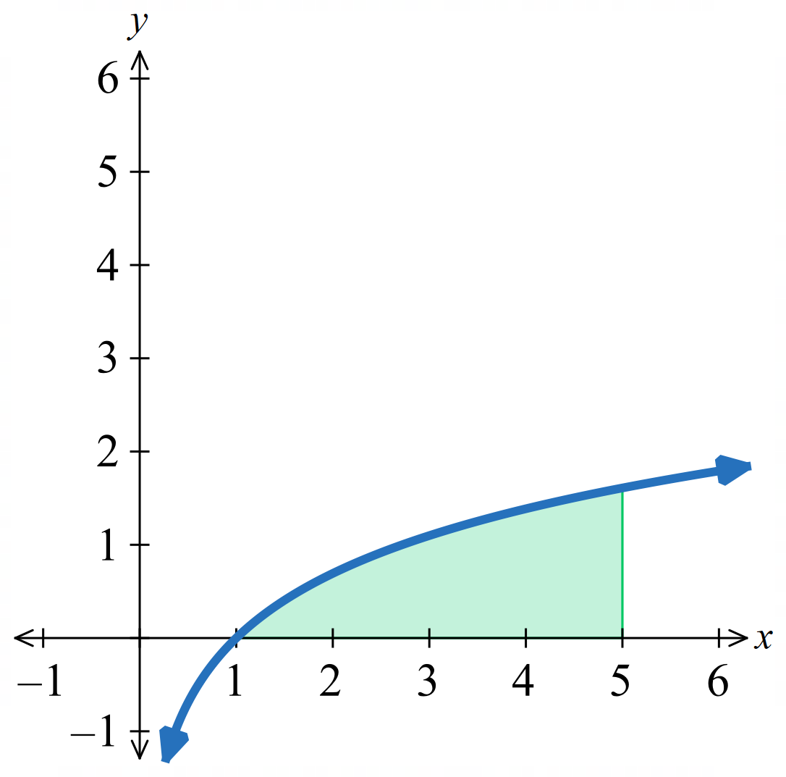  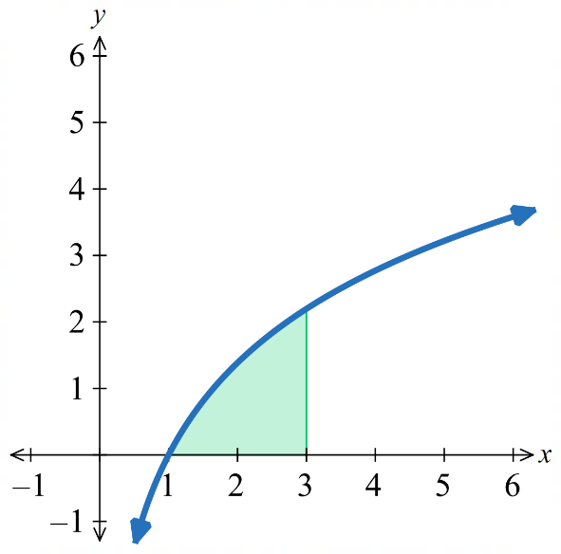  $$\int_{1}^{3}{2\ln{x}}dx$$  $$6\ln{3}-4$$

Mastery
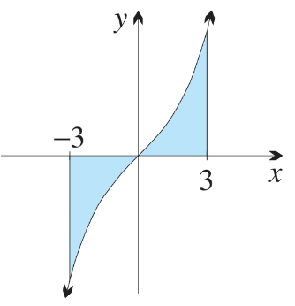
- The diagram shows the region between the curve $y = e^{x} - e^{-x}$, the $x$-axis and the lines
$x = -3$ and $x = 3$.

  - Show that $y = e^{x} - e^{-x}$ is an odd function.
$f(x) = eˣ - e^{-x}.$
$f\left(-x\right)= e^{-x}- eˣ = -f\left(x\right).$ So $f$ is odd.
  - Hence write down the value of $\int_{-3}^{3}{\left(eˣ - e^{-x}\right)dx}$ without finding a primitive.

$$\int_{-3}^{3}{\left(eˣ - e^{-x}\right)}dx = 0$$
  - Explain why the area of this region may be written as area = $2\int_{0}^{3}{\left(e^{x}- e^{-x}\right)dx}$.

The areas are equal by the odd symmetry

  - Hence find the area of this region.
$$2{\left[eˣ + e^{-x}\right]}_{0}^{3}$$
$$= 2\left[\left(e^{3}+ e^{-3}\right)- 2\right]$$
$$= 2\left(e^{3}+ e^{-3}- 2\right) u²$$

- In this question, give all approximations correct to four decimal places.
  - Find the area between the curve $y = e^{x}$ and the $x$-axis, for $0 ≤ x ≤ 1$, by evaluating an appropriate integral. Then approximate the result.

$$Area = \int_{0}^{1}{eˣ} dx = {\left[eˣ\right]}_{0}^{1}= e - 1 ≑ 1.7183$$
  - Estimate the area using the trapezoidal rule with two subintervals (that is, with three function values).

$$h = 0.5,f\left(0\right)= 1, f\left(0.5\right)= e^{0.5}, f\left(1\right)= e.$$
$$Area ≑ \left(\frac{0.5}{2}\right)\left(1 + 2e^{0.5}+ e\right)≑ 1.7539$$
  - Is the trapezoidal-rule approximation greater than or less than the exact value?
Give a geometric explanation.

The approximation is greater than the exact value. $y = eˣ$ is concave up $(y″ = eˣ > 0),$ so the chords lie above the curve.

  - Differentiate $e^{-x^{2}}$ and hence write down a primitive of $xe^{-x^{2}}.$

$$\frac{d}{dx}\left(e^{-x^{2}}\right)= -2xe^{-x^{2}}$$
$$So a primitive of xe^{-x^{2}}is -\left(\frac{1}{2}\right)e^{-x^{2}}.$$
  - Hence find the area between the curve $y = xe^{-x^{2}}$ and the $x$-axis from $x = 0$ to $x = 2$, and from $x = -2$to $x = 2$.

From $x = 0 to x = 2:$
$$\int_{0}^{2}{xe^{-x^{2}}}dx = {\left[-\left(\frac{1}{2}\right)e^{-x^{2}}\right]}_{0}^{2}=\frac{1}{2}- \left(\frac{1}{2}\right)e^{-4}$$
$f(x) = xe^{-x^{2}}$ is odd, so the signed integral from −2 to 2 is 0. The unsigned area from −2 to 0 equals the area from 0 to 2.
Total area from $-2 to 2 = 2\left(\frac{1}{2}- \left(\frac{1}{2}\right)e^{-4}\right)= 1 - e^{-4}u^{2}$

  - Find the two intersection points of the curve $y =\frac{1}{x}$with the line $y = 4 - 3x$.

$$\frac{1}{x}= 4 - 3x$$
$$3x² - 4x + 1 = 0$$
$$(3x - 1)(x - 1) = 0$$
$$x =\frac{1}{3}or x = 1.$$
$$Intersection points: \left(\frac{1}{3}, 3\right)and \left(1, 1\right).$$
  - Find the area between these two curves.

$$On \left[\frac{1}{3}, 1\right], the line y = 4 - 3x is above y =\frac{1}{x}.$$
$$Area = \int_{\frac{1}{3}}^{1}{\left(\left(4 - 3x\right)-\frac{1}{x}\right)}dx = {\left[4x -\frac{3x^{2}}{2}- ln x\right]}_{\frac{1}{3}}^{1}$$
$$= (4 - 3/2) - \left(\frac{4}{3}-\frac{1}{6}- ln\left(\frac{1}{3}\right)\right)$$
$$=\frac{5}{2}- \left(\frac{7}{6}+ ln 3\right)$$
$$= \left(\frac{4}{3}- ln 3\right)u^{2}$$

  - Evaluate the integral $\int_{N}^{0}{eˣ}dx$.
$$\int_{N}^{0}{eˣ} dx = {\left[eˣ\right]}_{N}^{0}= 1 - e^{N}$$
  - What is its limit as $N → -∞?$

$$As N → -∞, e^{N}→ 0.$$
$$Limit = 1.$$

  - Use the trapezoidal rule with four subintervals to approximate the area between the curve $y =\ln{x}$ and the $x$-axis, between $x = 1$ and $x = 5$. Answer correct to four decimal places.

$$h = 1, x = 1, 2, 3, 4, 5, f(x) = ln x.$$
$$Area ≑ \left(\frac{1}{2}\right)\left(\ln{1}+ 2\left(\ln{2}+\ln{3}+\ln{4}\right)+\ln{5}\right)$$
$$≑ 3.9828$$
  - Differentiate $y = x log_{e}x$. Hence find the exact value of the area, and approximate it correct to four decimal places.

$$\frac{d}{dx}\left(x\ln{x}\right)=\ln{x}+ 1$$
$$so \int{ln}x dx = x ln x - x + C.$$
$$Area = {\left[x ln x - x\right]}_{1}^{5}$$
$$= \left(5 ln 5 - 5\right)- \left(0 - 1\right)$$
$$= 5 ln 5 - 4 ≑ 4.0472$$
  - Is the estimate greater than or less than the exact value? Explain how the graph could have predicted this.

The estimate is less than the exact value. $y =$ ln $x$is concave down $\left(y^{″}= -\frac{1}{x^{2}}\right)$, so the chords lie below the curve.

  - Show that the curves $y =\frac{6}{x}$ and $y = x² - 6x + 11$ intersect when $x = 1, 2$ and $3$.
At $x = 1:\frac{6}{1}= 6 and 1 - 6 + 11 = 6$
At $x = 2:\frac{6}{2}= 3 and 4 - 12 + 11 = 3$
At $x = 3:\frac{6}{3}= 2 and 9 - 18 + 11 = 2$
so $\left(1,6\right) \left(2, 3\right) \left(3, 2\right)$ lie on both curves
  - Graph these two curves and shade the two areas enclosed by them.

  - Find the total area enclosed by the two curves.
On [1, 2]: parabola above hyperbola. On [2, 3]: hyperbola above parabola.
$$\int_{1}^{2}{\left(\left(x^{2}- 6x + 11\right)-\frac{6}{x}\right)}dx + \int_{2}^{3}{\left(\frac{6}{x}- \left(x^{2}- 6x + 11\right)\right)}dx$$
$$= \left(2 - 6 ln\left(\frac{4}{3}\right)\right)u^{2}$$

  - Sketch the region bounded by the graphs of $y = sin x$and $y = cos x$, and by the vertical lines $x = -\frac{π}{2}$and $x =\frac{π}{6}.$
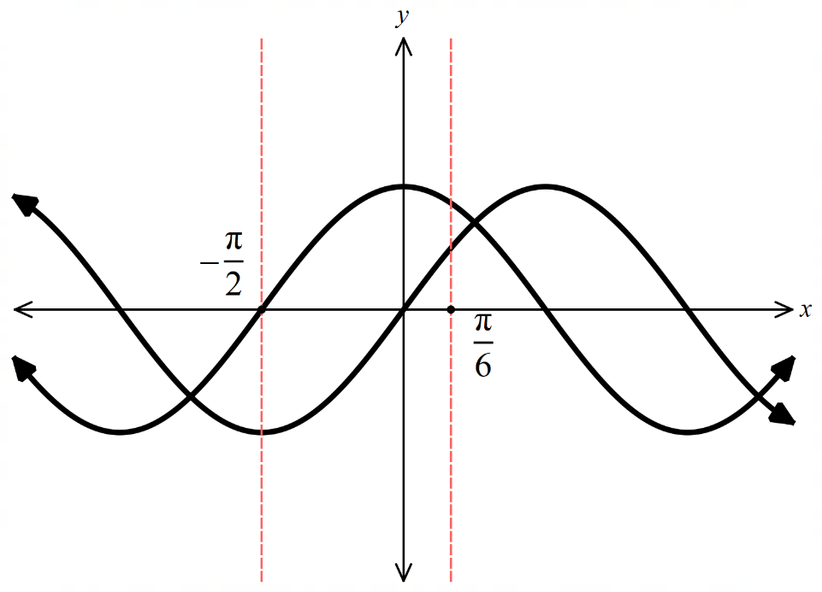
  - Find the area of the region in part a.

$$\int_{-\frac{π}{2}}^{\frac{π}{6}}{\left(cos x - sin x\right)}dx = {\left[sin x + cos x\right]}_{-\frac{π}{2}}^{\frac{π}{6}}$$
$$= \left(\frac{1}{2}+\frac{\sqrt{3}}{2}\right)- \left(-1 + 0\right)$$
$$=\frac{3 + \sqrt{3}}{2}u^{2}$$

  - Show by substitution that $y = sin x$ and $y = cos 2x$ meet at $x = -\frac{π}{2}$ and $x =\frac{π}{6}$.
$$\sin{x}=\cos{2x}= 1 - 2 sin^{2}x$$
$$2 sin^{2}x +\sin{x}- 1 = 0$$
$$\left(2 sin x - 1\right)\left(sin x + 1\right)= 0$$

$$\sin{x}=\frac{1}{2}, x =\frac{π}{6}$$
$$or sin x = -1, x = -\frac{π}{2}$$
  - On the same number plane, sketch $y = sin x$ and $y = cos 2x$, for $-\frac{π}{2}≤ x ≤\frac{π}{6}$.
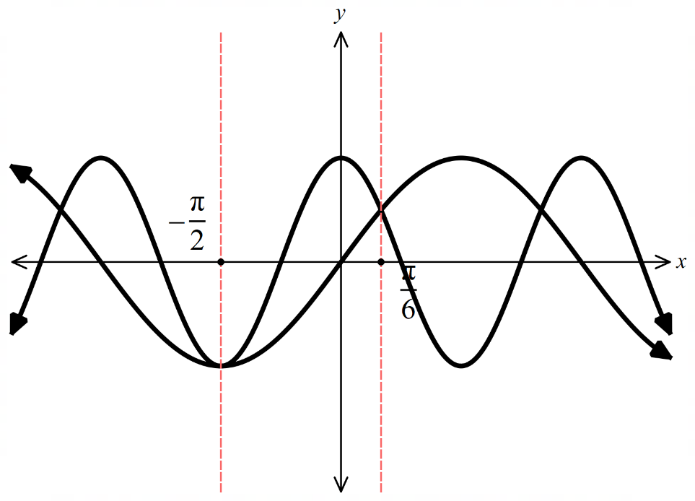

  - Hence find the area of the region bounded by the two curves.
$$On \left[-\frac{π}{2},\frac{π}{6}\right], cos 2x ≥ sin x.$$
$$\int_{-\frac{π}{2}}^{\frac{π}{6}}{\left(cos 2x - sin x\right)}dx = {\left[\left(\frac{1}{2}\right)sin 2x + cos x\right]}_{-\frac{π}{2}}^{\frac{π}{6}}$$
$$= \left(\frac{\sqrt{3}}{4}+\frac{\sqrt{3}}{2}\right)- \left(0 + 0\right)$$
$$= 3\frac{\sqrt{3}}{4} u²$$

- Use symmetry to help evaluate:
  - $\int_{-4π}^{4π}{sin}3x dx$
$sin 3x$ is odd, symmetric limits. $\int_{-4π}^{4π}{sin}3x dx = 0$
  - $\int_{-2π}^{2π}{cos^{2}x}sin^{3}x dx$

cos² x sin³ x is odd (even × odd = odd), symmetric limits. So integral = 0
  - $\int_{-\frac{5π}{2}}^{\frac{5π}{2}}{cos}x dx$
$$\cos{x}is even. 2\int_{0}^{\frac{5π}{2}}{cos}x dx = 2{\left[sin x\right]}_{0}^{\frac{5π}{2}}$$
$$= 2 sin\left(\frac{5π}{2}\right)$$
$$= 2$$
  - $\int_{-π}^{π}{sec^{2}\left(\frac{x}{3}\right)dx}$
$$sec^{2}\left(\frac{x}{3}\right)is even. = 2\int_{0}^{π}{sec^{2}\left(\frac{x}{3}\right)}dx = 2{\left[3 tan\left(\frac{x}{3}\right)\right]}_{0}^{π}$$
$$= 6 tan\left(\frac{π}{3}\right)$$
$$= 6\sqrt{3}$$
  - $\int_{-π}^{π}{\left(3 + 2x + sin x\right)dx}$
3 is even → so $2\int_{0}^{π}{3} dx = 6π.$
$2x$ is odd → contributes 0.
sin $x$ is odd → contributes 0.
Total = $6π$
  - $\int_{-\frac{π}{2}}^{\frac{π}{2}}{\left(sin 2x + cos 3x + 3x^{2}\right)dx}$
sin 2$x$ is odd → contributes 0.
$$\cos{3x}is even → 2\int_{0}^{\frac{π}{2}}{cos}3x dx = 2{\left[\left(\frac{1}{3}\right)sin 3x\right]}_{0}^{\frac{π}{2}}$$
$$= \left(\frac{2}{3}\right)\left(-1\right)= -\frac{2}{3}$$
$$3x^{2} is even → 2\int_{0}^{\frac{π}{2}}{3x^{2}}dx = {\left[2x^{3}\right]}_{0}^{\frac{π}{2}}$$
$$=\frac{π^{3}}{4}$$
$$Total = -\frac{2}{3}+\frac{π^{3}}{4}$$

  - Evaluate the integral $\int_{0}^{N}{e^{-x}dx}$.

$$\int_{0}^{N}{e^{-x}}dx = {\left[-e^{-x}\right]}_{0}^{N}= 1 - e^{-N}$$
  - What is its limit as $N → ∞?$
$$As N → ∞, e^{-N}→ 0.$$
$$Limit = 1.$$

  - Show that $\sqrt{2}sin\left(x +\frac{π}{4}\right)= sin x + cos x.$
$$\sqrt{2} sin\left(x +\frac{π}{4}\right)$$
$$=\sqrt{2}\left(sin x cos\left(\frac{π}{4}\right)+ cos x sin\left(\frac{π}{4}\right)\right)$$
$$= \sqrt{2}\left(\frac{sin x + cos x}{\sqrt{2}}\right)$$
$$= sin x + cos x$$
  - Hence, or otherwise, find the exact area under one arch of the curve $y = sin x + cos x$.

$$One arch of y = sin x + cos x = \sqrt{2} sin\left(x +\frac{π}{4}\right), from x = -\frac{π}{4}to x =\frac{3π}{4}.$$
$$\int_{-\frac{π}{4}}^{\frac{3π}{4}}{\sqrt{2}}sin\left(x +\frac{π}{4}\right) dx = {\left[-\sqrt{2}cos\left(x +\frac{π}{4}\right)\right]}_{-\frac{π}{4}}^{\frac{3π}{4}}$$
$$= \sqrt{2}+ \sqrt{2}$$
$$= 2\sqrt{2} u^{2}$$
- Similarly, evaluate $\int_{0}^{N}{2xe^{-x^{2}}dx}$, and find its limit as $N → ∞.$

$$\int_{0}^{N}{2xe^{-x^{2}}}dx = {\left[-e^{-x^{2}}\right]}_{0}^{N}= 1 - e^{-N^{2}}$$
As $N → ∞, e^{-N^{2}}→ 0$.
Limit = 1.

  - Show that $\int_{0}^{n}{\left(1 + sin 2πx\right)dx}= n$, for all positive integers $n$.

$$\int_{0}^{n}{\left(1 + sin 2πx\right)}dx = {\left[x - \left(\frac{1}{2π}\right)cos 2πx\right]}_{0}^{n}$$
$$= \left(n -\frac{1}{2π}\right)- \left(0 -\frac{1}{2π}\right)$$
$$= n$$
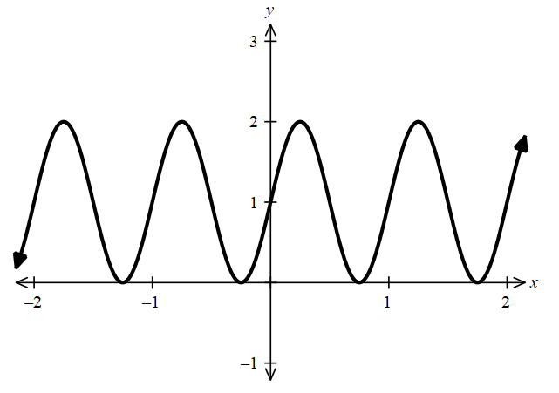
  - Sketch $y = 1 + sin 2πx$, and interpret the result geometrically.

$y = 1 + sin 2πx$ oscillates about $y = 1$ with period 1.
The positive and negative deviations from $y = 1$ cancel, so the area equals the area of a rectangle $n$ units long and 1 unit high.

  - Using the fact that $sin x < x < tan x$ for $0 < x <\frac{π}{2}$,
explain why $x² sin x < x³ < x² tan x$ for $0 < x <\frac{π}{2}$.

$$For 0 < x <\frac{π}{2}: sin x < x < tan x and x^{2}> 0. Multiplying through by x^{2}:$$
$$x² sin x < x³ < x² tan x$$

  - Hence show that $\int_{0}^{\frac{π}{4}}{x^{2}sin}x dx <\frac{π^{4}}{4^{5}}< \int_{0}^{\frac{π}{4}}{x^{2}tan}x dx$.

$$\int_{0}^{\frac{π}{4}}{x^{2}sin}x dx < {\left[\frac{x^{4}}{4}\right]}_{0}^{\frac{π}{4}}< \int_{0}^{\frac{π}{4}}{x^{2}tan}x dx$$
$$\int_{0}^{\frac{π}{4}}{x^{2}sin}x dx <\frac{π^{4}}{4^{5}}< \int_{0}^{\frac{π}{4}}{x^{2}tan}x dx$$

  - Given that $y =\frac{1}{1 + sin x},$ show that $y^{'}= -\frac{\cos{x}}{{\left(1 + sin x\right)}^{2}}.$

$$y = {\left(1 + sin x\right)}^{-1}$$
$$y' = -\frac{\cos{x}}{{\left(1 + sin x\right)}^{2}}$$
  - Hence explain why the function $y =\frac{1}{1 + sin x}$ is decreasing for $0 < x <\frac{π}{2}.$

$For 0 < x <\frac{π}{2}: cos x > 0 and {\left(1 + sin x\right)}^{2}> 0, so y^{'}< 0. Hence y is decreasing$.
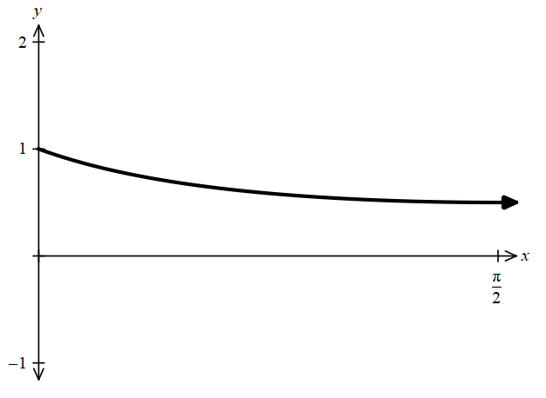
  - Sketch the curve for $0 ≤ x ≤\frac{π}{2}$, and hence show that $\frac{π}{4}< \int_{0}^{\frac{π}{2}}{\frac{1}{1 + sin x}}dx <\frac{π}{2}.$

$$Since y is decreasing on \left[0,\frac{π}{2}\right]: y\left(\frac{π}{2}\right)≤ y\left(x\right)≤ y\left(0\right),$$
$$\frac{1}{2}≤\frac{1}{1 + sin x}≤ 1.$$
$$Integrating: \left(\frac{1}{2}\right)\left(\frac{π}{2}\right)≤ \int_{0}^{\frac{π}{2}}{\frac{1}{1 + sin x}} dx ≤ \left(1\right)\left(\frac{π}{2}\right)$$
$$\frac{π}{4}< \int_{0}^{\frac{π}{2}}{\frac{1}{1 + sin x}} dx <\frac{π}{2}$$

